6th class Work at Home June 15th -19th 2020
SPHE
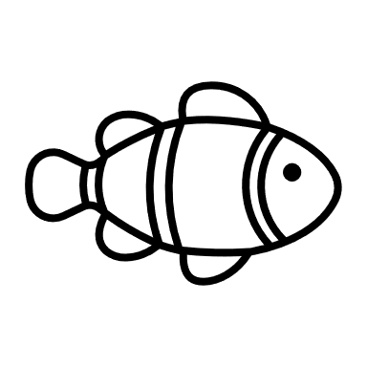
From Big Fish to little Fish
- Read pg17 ‘What type of learner are you?’ – outlines study tips for your style of learning.
- Read p18 ‘Note Taking Styles’ – outlines different ways of taking notes when you are in class or studying. You will find a way, or a combination of ways, that works best for you.
- Look at p20, p21, p22–blank templates of the ‘note taking styles’ described.

Cycle Safety 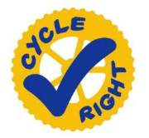
Cycling is fun and sociable and, like swimming, a life-skill that stands to children in later years. Yet, like many activities, cycling carries an element of risk. It is important that children get proper guidance and instruction at an early age to ensure that basic safety rules are absorbed while young. Cycle Right is the National Standard for Cycle Training. It provides practical cycle safety and skills training to promote competent and confident cyclists

- Read this ONLINE BOOKLET about cycle safety. The link is also copied below.
- Answer the ten short questions at the end of the outline. Check your answers as soon as you are finished to make sure you have the right information. The answers are in a separate attachment.

https://www.rsa.ie/Documents/Campaigns/Wrecked/Downloads/Cycle%20safety%20booklet.pdf

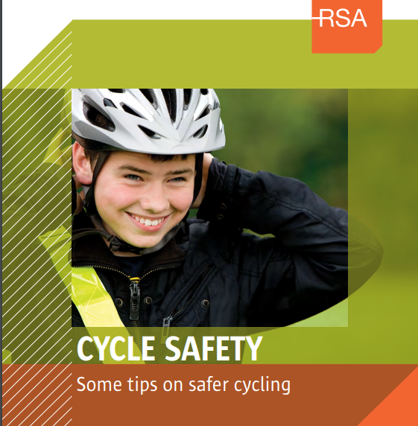

- Watch these short videos on cycle safety. You may have seen them last year on the cycle safety course you did but they are well worth watching again.
- Short video on wearing a helmet.
https://vimeo.com/288768008
- Check your bike before cycling.
https://vimeo.com/288767022
- Cycling safely/blind spots
https://vimeo.com/288776306
- Cycling tips
https://vimeo.com/288041443
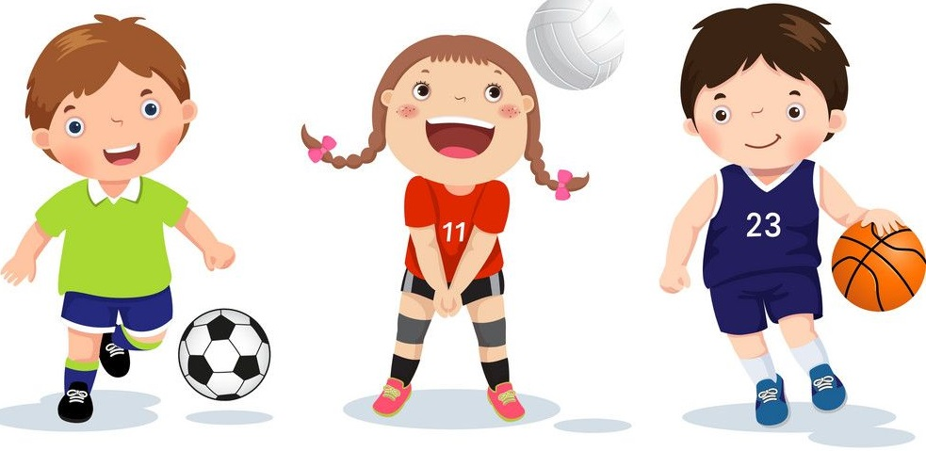
Scoil Mochua Sports Week
Choose from the Activities and challenges below, try as many as you like.
You could also try some of the activities from ‘Sports Day At Home’ PowerPoint.
5 km Run/Walk Challenge
- Set a target on Monday and try to reach your target distance by Friday.
- Your target could be 2km or even 10km! Whatever you think you can achieve.
- Try to run or walk a bit each day, you could get your siblings, parents or even your dog involved!

Activity circuit - Using the ‘Activity Circuit’ cards, try to do each activity, one after another. Repeat the circuit as many times as you like.
Long Puck –– You’ll need a hurl and a ball and in a safe, open, outdoor location. See how far you can hit the ball or find a partner and hit the ball to each other.
Welly Toss – In a safe, open, outdoor location, put on one welly and fling it, from your foot, as far as you can. See who can fling it the furthest!
Balance challenge – Standing on foot, time yourself and see how long you can balance.
Target challenge – In safe area, and with permission, choose a target (a hula hoop, a skipping rope/chalk circle), place down a marker a short distance from the target and see how many objects (bean bags, pegs, etc) you can get into the circle, in a minute.
Kids Yoga – Try a series of yoga poses using the ‘Yoga’ Power point.
Scavenger Hunt – Complete a scavenger hunt using the ‘Scavenger Hunt’ activity card.
Sports:
Football Basketball Gymnastics Hockey/Hurling/Camogie Gaelic Football Rugby Swimming Dance Handball Tennis/Badminton Judo/Karate

Name: | Class:

Day | Activity
Monday

Tuesday

Wednesday

Thursday

Friday

Cycle Safety-Some Tips on safer cycling
Answer these questions (no need for full answers)
- Is it law to have a bell on your bike and working lights?
- A helmet reduces the risk of you getting a head injury by ______________ per cent.
- The RSA recommends that children younger than ________ should not ride bicycles in any type of traffic. (what age?)
- Is it ok to wear an mp3 or iPod to listen to your music while cycling?
- Is it ok to cycle side by side with two more friends?
- What should you do if a traffic light turns amber as you approach?
- What should you do before you signal?
- Give two examples of times you should signal.
- How much space should you leave when overtaking a parked vehicle?
- Give one piece of advice for parking your bike.

