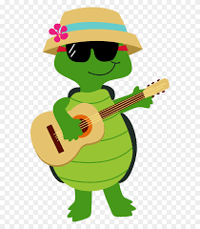
Hello fifth class…
Can you believe the school year is almost finished? This will be our last week assigning work and we would like to thank you and congratulate you on all your hard work over the last few weeks. It has certainly been a term to remember, you should all be very proud of yourselves and we certainly are. We hope you all enjoyed sports week last week, we really enjoyed looking at all the activity you got up to on our Padlet, well done for the great effort. You can continue to post on the Padlet pages this week - we have one for physical activity, STEM and we have added a cooking Padlet where you can share any meals you make or help prepare.
This week we have included some virtual school tours for you to check out as well as some English riddles, Art and SPHE. As we finish up with 5th class we would like to remind you to put away all your books, including any library books you have, keep them safe for the summer and return them to us in September. As the summer approaches we would like to remind you to try and read every day, there is simply nothing better you can do and no limit to where your imagination can take you. Check out the school's home page for some wonderful summer programmes the Celbridge Library are running this year, there is even a creative writing competition where you could win a tablet!

Enjoy the last full week in 5th class!!
Mr Costello, Ms Nolan Ms Arnold

Virtual tours:

- Ms. Donaldson very kindly has put together a video of photos/videos of the different landscapes and cities across Canada as a virtual school tour. They are personal photos she collected from her family and friends so very different to what you would normally see. I think Newfoundland was one of my favourites, what will yours be? https://youtu.be/m6nCjniRnmE
- Anne Frank: https://www.annefrank.org/en/museum/web-and-digital/
- San Diego Zoo Kids https://kids.sandiegozoo.org/ Check out your favourite animal or learn about some new ones on a tour of San Diego Zoo.
- Burj Khalifa https://www.google.com/maps/about/behind-the-scenes/streetview/treks/burj-khalifa/ Check out the largest building in the world.
- Angkor Wat https://www.google.com/maps/about/behind-the-scenes/streetview/treks/angkor/ Do a virtual tour of the lost temples of Angkor Wat
- International Space Station
https://www.google.com/maps/space/iss/@29.5603465,-95.0853519,2a,75y,214.43h,95.7t/data=!3m6!1e1!3m4!1sH344uAn0-24AAAQvxgbyDw!2e0!7i10000!8i5000Do a virtual tour of the international Space Station.
- The White House https://artsandculture.google.com/partner/the-white-house
Visit Donald Trump’s current house.

English Riddles:
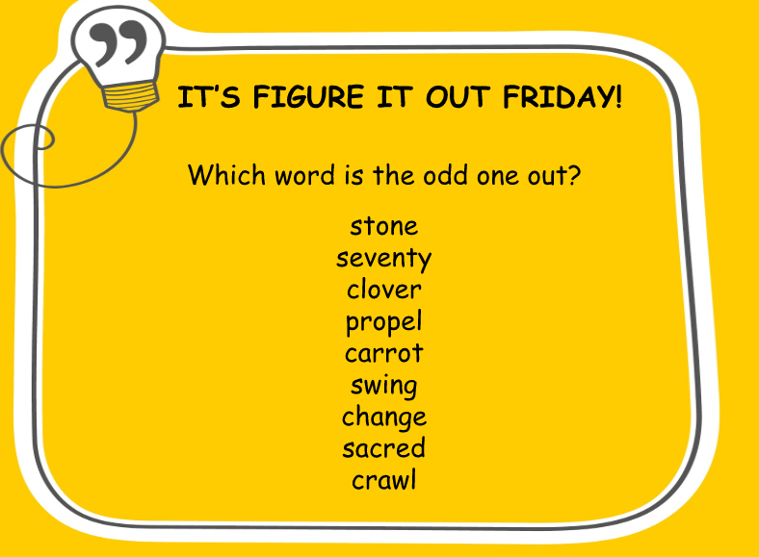
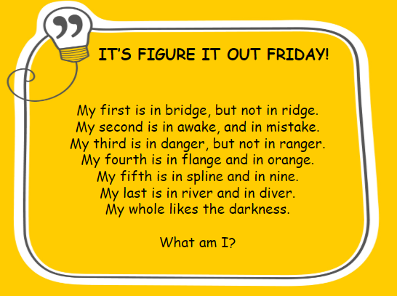
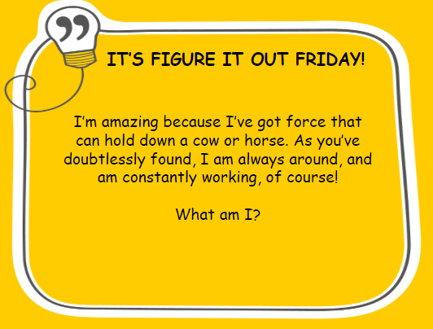
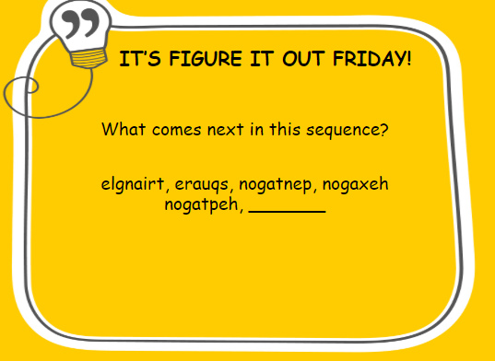
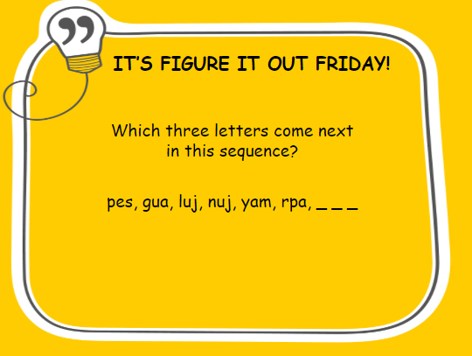
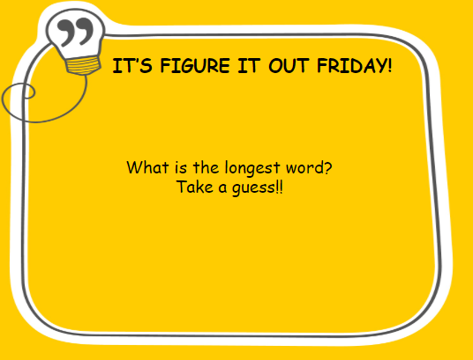

S.P.H.E:
- Design and create an information poster for younger children on road safety.
- Include a slogan.
- You might consider what dangers they might face getting to school.
- Include important information needed to stay safe on or near our roads.

Please read through this brochure for more information: https://www.rsa.ie/Documents/Road%20Safety/Leaflets/Leaf_booklets/Going_to_school.pdf

Art activities:
Recreate a famous piece of art - use yourself or other family members and items around the house. Click on this link for ideas recreating-famous-paintings-
