4th Class Learning from Home: June 22nd – June 26th 2020
Dear parents, boys and girls,
Can we just say firstly, how great it was to see all the amazing things you got up to on Padlet over the last couple of weeks. You have really embraced the activities we assigned and it has been really heart-warming to see you all enjoying yourselves after what has been a difficult few months.
We hope you all enjoyed sports week and even though the weather wasn’t as good as it has been, managed to get out and get active.
This will be our last time assigning work from home, although we will be sure to check in with you next week before the summer holidays. As ever, we hope you undertake the activities with the same enthusiasm you have shown up to now. One of our colleagues, Ms. Donaldson, has put together a virtual tour of Canada, which we hope the children will enjoy. Ms. Donaldson is from Canada and has asked friends and family to send pictures of some amazing places, which she has turned into a video.
Lastly, we would just like to draw your attention to two resources which are linked to on the 4th class page of the website. One is on water safety and the other is on road safety. We would urge you to explore and discuss these resources with your child before the summer holiday.
That’s it from us. Have a great week!
Mr. Murphy, Ms. Gamble and Ms. Burns.
______________________________________________________________________________
Make and Do Monday
- Create a Marble Maze - Create a maze using whatever materials you have at home. You could use Lego, playdough, whatever you have. You could challenge a family member to solve the maze or try to race a marble or small ball through it.
- Make a flower chain crown- Collect flowers with long stems (Daises and Dandelions work very well). Place two flowers side by side. Loop the stem of the second flower underneath the first flower’s stem (see pictures).
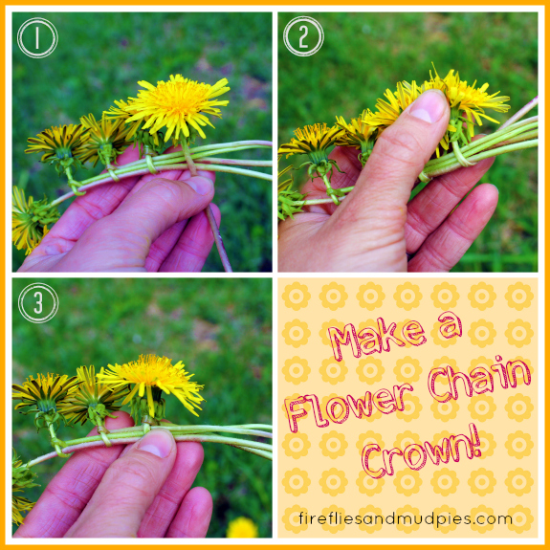
- Recreate a famous piece of art - use yourself or other family members and items around the house. Click on this link for ideas recreating-famous-paintings-

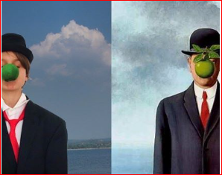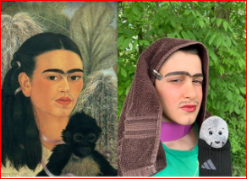
- Make a photo frame from twigs (follow the instructions below).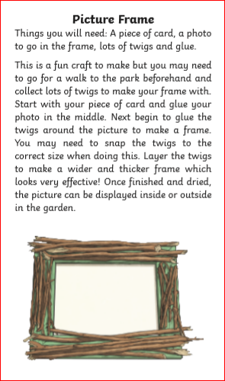

______________________________________________________________________________
Thinking Tuesday
- Design and make an umbrella or any device that will keep you dry in a rain shower.
You can judge how effective it is by asking a brother/sister/parent to pour some water over you as you stand under the device.

- Build a tower to match your own height! It can be built using your choice of materials. Take a picture of you beside the tower and post to the 4th Class Padlet.

- How many times can you say your name in a minute?? Time yourself using a stopwatch and see how many times you can repeat your name in a minute. Don’t forget to estimate before you begin. You may choose to just use your first name or both! Have a few goes and record your results. Maybe even make a video of you doing it for fun.

- Build a bridge to hold some toy cars - Using materials you have at home, build a bridge that is strong enough to hold some toy cars. Think carefully about the design of your bridge! Look at the structure of different bridges online before you begin. Post some pictures to the 4th Class Padlet.

_____________________________________________________________________
Where Are We Off To Wednesday
- Let your imagination take you anywhere –
Listen to the wonderful storytelling of Niall De Burca and let your imagination take you away on an adventure.
Click on the links below to access the stories.
Gifts to The World - Freckles!
https://youtu.be/PCW-Oswz6KE

Shapeshifter - Traditional
https://www.facebook.com/KildareCountyLibraryService/videos/553593642250770/

Balor of The Evil Eye - Irish Myth
https://youtu.be/-R6GYcQe-60

The Two Hunchbacks - Traditional Tale
https://youtu.be/nUjTm5_M5NE

- The Natural History Museum – click on the link below to take a tour of the museum answer the questions as you go. The answers will be posted up on the website,
https://www.cliste.ie/library1/Natural-History-Museum-Dublin-Virtual-Tour.pdf

- The life of the Blue Whale – click on this link to explore the many interesting facets of the life of the blue whale https://www.nhm.ac.uk/bluewhale/

- Take a virtual tour of Canada, created especially for the children of Scoil Mochua! – https://youtu.be/m6nCjniRnmE
___________________________________________________________________

Tasty Thursday
- Really simple no-bake cookies -

Ingredients
1 Cup sugar
1/2 cup milk
1/2 cup stick butter
1/4 cup peanut butter
2 tbsp cocoa
1 cups oats
1 tsp vanilla essence

How to Make No Bake Cookies
Take sugar in a pan; add butter and milk. Let the sugar dissolve in milk. Keep aside for 10 minutes.
In a bowl, take oatmeal, cocoa, peanut butter and vanilla essence. In this dry mix, add the sugar-milk mix and stir evenly.
Take a spoonful of the batter and flatten it out into round shapes. Put on a platter and chill till set.

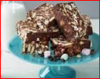
- Rocky Road Bars.
Break 600g of chocolate into a bowl (non-metal)
Add 130g of butter and 200g golden syrup.
Melt in the microwave for 3 minutes and stir well.
Break 300g of biscuits (Digestive/Rich Tea) into bite-size pieces.
Add the broken biscuits to the chocolate mix and stir / combine together.
Add 160g Maltesers.
Add 50g mini marshmallows,
Stir well until everything is coated in chocolate.
Pour into a lined tin and refrigerate until set.
Ask an adult to cut into bars.
Enjoy!!!!!!
Post pictures on the 4th Class Padlet

- Simple Pizza – Follow the simple instructions below for a lovely lunchtime treat.
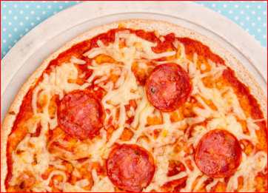

Place a wrap on a clean kitchen counter.
To make your pizza sauce mix together; 1 teaspoon of tomato puree, 4 tablespoons of passata, half a teaspoon of mixed herbs, half a teaspoon of garlic salt/granules.
Spread the tomato sauce all over the wrap, but leave a little space around the edges.
Add whatever toppings you like; mushrooms, onions, peppers, ham, pepperoni, sausage, chicken, pineapple.
Don’t forget to sprinkle on the cheese on top.
Ask an adult to place the pizza in a pre-heated oven at 160C for 7-8 minutes.
Slice with a pizza cutter and enjoy!
- Share your favourite recipe with your teacher. Post a picture of your completed dish on the 4th Class Padlet.

______________________________________________________________________

Fit Friday

- For fit Friday, pick 1-3 activities from the Sports Week menu that you didn’t do during Sports Week and give them a go! Make sure and post pictures to the 4th class Padlet.
4th Class Padlet

