4th Class Learning from Home: June 8th – June 13th 2020
Dear parents, boys and girls,
Well done to all of you for everything you have done so far during school closure. We know it hasn’t been easy. Judging by the excellent work we have received, it looks like you have made the most of the time off by developing some skills, reading lots of books and hopefully learning some new things along the way.
This week, the school work will consist of more fun activities so we hope you can all find things to do that are relaxing, rewarding and enjoyable! Each day is themed with a menu of activities to choose from. You can do as many or as little of the options as suits, but we would like to see you give at least one thing a go each day.
That’s it from us. Enjoy the week!
Mr. Murphy, Ms. Gamble and Ms. Burns.
______________________________________________________________________________
Make and Do Monday
- Safety in the Sun Poster Challenge–
Please design a poster advising people how to stay safe in the sun.

Your poster should be bright and colourful and include important information such as:
- Cover up by wearing a T-shirt
- Wear sunscreen
- Wear sunglasses
- Stay in the shade
- Wear a hat to protect your head, ears, neck and face.
- Drink lots of water.
- Design your ideal school uniform.
Post a photo of your design on the 4th Class Padlet.
- Make a den – follow the instructions below.
Post a photo of your den on the 4th Class Padlet.

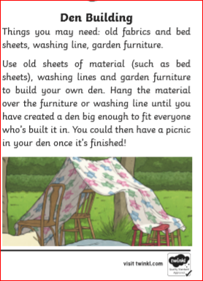
- Make a summer scene collage – using old newspapers, magazines, food wrappers, leaves, grass etc.
______________________________________________________________________________
Thinking Tuesday
- Family Name and Crest
Research your own family name on https://forebears.io/surnames and find out:
• What is the meaning of your surname?
• From where does it originate?
• How many people in the world have this surname?
• Which country has the highest number of people with your surname?
Find your family crest on https://www.thetreemaker.com/family-coat-of-arms.html
Make a poster of your family name that includes all the information you’ve discovered and your family crest

- Design and create a chair - you can only use newspapers/ Lego/ card / fabric and cardboard, your chair must be freestanding, it should be at least 10cm in height and it must be able to hold at least one teddy. Please take a photo of your chair and post on the 4th Class Padlet.
- Design and make a bird’s nest strong enough to hold an egg – use only materials that birds would use such as twigs, leaves, moss, feathers and ivy. Is your nest strong enough to hold an egg without falling through? Test it out. Post photos of your nest and egg on the 4th Class Padlet.
- 3D Shape name - Create your name using 3D shapes (household items likes cans/jars etc). Remember a 3D shape is a shape that has length, width and height. You can create your first and last name if you wish. You could create your siblings' names too! Post some pictures to the 4th Class Padlet

_____________________________________________________________________
Where Are We Off To Wednesday
- Dublin Zoo – take a virtual tour of the zoo by clicking on this link https://www.dublinzoo.ie/virtual-tours-2/

- Yellowstone National Park– take a tour of Yogi Bear’s homeland by clicking on the link Yellowstone National Park Virtual tours

- Back in time – Interview a grandparent or parent about how they used to spend their summer holidays.

- Your bedroom or sitting room - The story of a room. A room can be a lot like a person: it sees stories and parties and bored days and birthday cakes. And sometimes it sees sad things, too.’ Write a story from the point of view of your sitting room or bedroom.
______________________________________________________________________

Tasty Thursday
- Make your own ice-cream.
Click on the link and follow the instructions. Ice-cream in a bag instructions

- Make a tasty treat for the birds by following the instructions below.
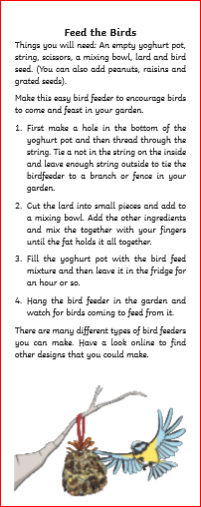

- Banana Pancakes – Follow the instructions in the link to make these simple pancakes. /how-to-make-2-ingredient-banana-pancakes
- Share your favourite recipe with your teacher. Post a picture of your completed dish on the 4th Class Padlet.
______________________________________________________________________

- Fit Friday

- 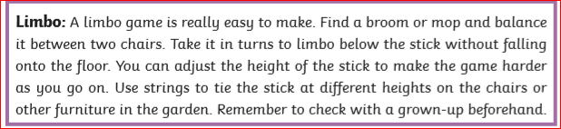

- 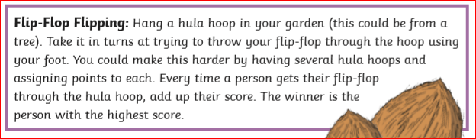

- Create your own obstacle course in your garden – use garden furniture, skipping ropes, hula-hoops and anything else you can find. What is your fastest time to complete the obstacle course? Can you beat your parents/ brother/sister?
Don’t forget to post photos of your obstacle course on the 4th Class Padlet

- Can you beat 10,000 steps today?
______________________________________________________________________

