6th class Work at Home 6^{th –} 8th May
We hope that everyone got to enjoy the sunshine over the weekend. It is a short week this week. As usual, do what you can do. If you need help or clarification on anything, please email your teacher
What you will need:
Figure it Out Worksheet
Optional: Capacity Challenge Cards
Maths copy
PDF of Wonder
Questions on chapters
Dán- Cad atá Uait don Bharbaiciú

PowerPoint/exercise on A.F.
Project brief etc.
Homework copy (all work apart from maths can be done here)
www.scoilmochua.com

B
Please correct last week’s work using answers for self-correcting on the school website. This is part of your work for the week as we would like to know if you are having any difficulties.
Maths
- Figure it Out-Capacity Worksheet attachment. There are 24 written problems and 24 mental problems. Do as many as you can, spending 30mins on maths daily.

- Practice maths facts using
https://www.abcya.com/grades/6/numbers
Math Fact Shoot-Out is a good one to try first.
Do ‘medium’ level or ‘hard’ for a challenge.

- Optional challenge-Capacity Challenge Cards
Write down your answer as you go along and check your score out of twenty at the end. Do ‘medium’ level or ‘hard’ for a challenge.
English

- ‘Wonder’. A PDF copy was attached on the outline dated 20th April. The novel is also available on ‘Audible’ and they are doing a 30day free trial.
Read Page 65 (Part 2: Via, A Tour of the Galaxy) to end of page 76 (end of chapter Breakfast).

You should read about 5 pages a day and answer the questions for the chapters, also attached, as you finish the chapters. You do not need to write full sentences.

Gaeilge
- Seanfhocal na Seachtaine-draw a picture and write the proverb. Send finished proverb into your teacher.
Nuair a bhíonn an bolg lán is maith leis na cnámha síneadh.
When the belly’s full the bones like to stretch; when you’ve had a good meal, you like to relax.

- Read only: Poem Cad atá Uait don Bharbaiciú Le Dominic Ó Braonáin (at the end of this outline)

- Grammadach: go through Scoilnet PowerPoint on Aimsir Fháistineach (future tense), An Dara Reimniú, briathra leathana (broad verbs)

- Do worksheet (uploaded onto website) out into copy. Do the part in the table orally and full sentences for questions 1-8.

SESE

- Geography-
Project on Greece-See brief at the end of the outline for details. We have also provided some recommended website and attached various resources on different aspects of Greece.
Finished project can be emailed or uploaded and ‘turned in’ on Google Classrooms.

Project Brief
You are required to complete a project on the country, Greece. This project can be done in a word document or as a PowerPoint, so it can then be easily sent to your class teacher. If you don’t have access to this, you can do your project on paper and photographs can be taken and sent to your class teacher.
Areas that must be covered:
- Physical Greece (map- mountains, rivers, islands)
- Fact file of Greece (flag, population, language, Government, currency, bordering countries, popular food)
- History/Ancient Greece (Gods, traditions, education, daily life, food)
- Greek myths/legends- the Trojan Horse, the Midas touch, Achilles Heel, the minotaur, The Odyssey, The Labours of Heracles (can do a summary or choose one in detail)
- The first Olympic Games
- Greek vocabulary/alphabet
- Famous landmarks
- Famous people (list some and why they are famous, choose one to discuss in detail)
- Greek Islands (list some and choose one to focus on)

You can choose any other additional areas that you may like to cover such as: Delphi, Alexander the Great, Corinth Canal etc.
Make sure that all information is researched by you and written in your own words and not just copied from the internet.
Use the links, that we have emailed, to assist you with your project. There is a list, following this brief, of some other websites to help with your own research too. Add in pictures and try to make it look nice as well as being informative. Looking forward to seeing all your lovely work and how much you learn about Greece!
Deadline: 22nd May

Websites for project research

www.Dkfindout.com
https://kids.nationalgeographic.com - National Geographic Kids
www.ducksters.com
https://www.greeka.com/greece-geography/
http://www.primaryhomeworkhelp.co.uk/greece/today.html

Search engines for children
www.Kidzsearch.com (most recommended)
www.Kiddle.com

Cad atá Uait don Bharbaiciú
Foclóir
Cad atá uait? -what would you like?
Sionnach-fox
Úr-fresh
Peist-worm
Spideog-robin
Cuileog-fly
Ag gol-ag caoineadh (crying)

“Cad atá uait don bharbaiciú?
Sicín, iasc nó feoil?”
“Sicín,” arsa an sionnach,
“Agus sú oráistí le hól”.
“Cad atá uait don bharbaiciú?
Sicín, iasc nó feoil?”
“Iasc”, arsa an cat
“Agus bainne úr le hól”.
“Cad atá uait don bharbaiciú?
Sicín, iasc nó feoil?”
“Peist,” arsa an spideog,
“Agus uisce deas le hól”.
“Cad atá uait don bharbaiciú?
Sicín, iasc nó feoil?”
“Cuileog,” arsa an frog
“Agus líomanáid le hól”.
“Cad atá uait don bharbaiciú?
Sicín, iasc nó feoil?”
“Sailéad”, arsa an turcaí-
Agus thosaigh sé ag gol.

Le Dominic Ó Braonáin

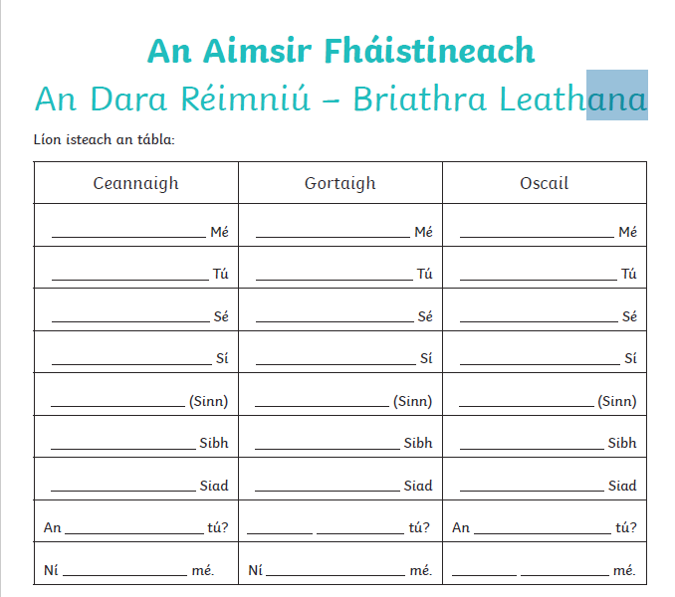

Scríobh amach na freagraí (write out)
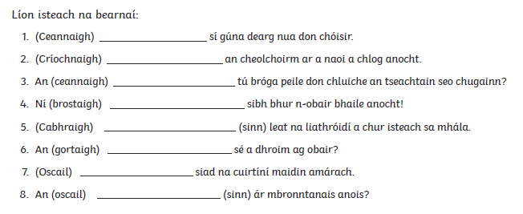

Figure it Out-Capacity
Remember! $\frac{3}{4}$ or 0.75 Litre is 750ml
$\frac{1}{2}$ 0r 0.5 Litre is 500ml
$\frac{5}{8}$ Litre is 725ml

