6th class Work at Home April 27th-May 1st 2020
We understand that all children work at different paces and have different circumstances. If you feel this is too much work for your child or the work is too difficult, prioritise the reading and select what they can do.
What you will need:
Mathemagic 6
Maths copy
Optional maths exercises
PDF of Wonder
Questions on chapters
Bun go Barr 6
Ábairtí Úsáideacha help sheet
PowerPoint/exercise on A.F.
Earthlink 6th class (online or screenshots)
Homework copy (all work apart from maths can be done here)
www.scoilmochua.com

B
Correct last week’s work using answers for self-correcting on the school website
SPHE
Refer to last week’s advice on protecting yourself and others from contacting Covid-19.
PE
This week is usually Active Schools Week. This year it is Active HOME week. Check out this website if you get a chance.
https://activeschoolflag.ie/index.php/active-home-week-2020/#toggle-id-1
There is a lovely chart where children can do a 60-minute-a-day-challenge and lots of nice ideas about staying active.
Maths
- Mathemagic 6, chapter 38, pgs. 159+160
Language: capacity- the amount a container or something
can hold.

Remember! 1 litre = 1000 millilitres Abbreviations
500 mL = half a litre millilitre, mL
litre, L
To find a fraction of a number divide the number by the denominator (bottom number) and multiply by the numerator (top number)
e.g. $\frac{3}{8}$ of 2L 2000÷8=150 150x3=450
answer is 450Ml

- Practice tables daily using
https://www.topmarks.co.uk/maths-games/hit-the-button
Try to beat your score!

- Optional challenge-Oh! Harry!
This problem is located at the end of this outline. It can be done if you get work completed or it can be done instead of some of the work in the chapter as it is good for developing problem solving strategies.

- Optional-Master Your Maths Week 20
These exercises are also found at the end of the outline and can be done if you need extra work.
English

- ‘Wonder’. A PDF copy was attached last week. The novel is also available on ‘Audible’ and they are doing a 30day free trial.
Read Page 37 (from Around the Room) to end of page 62 (end of chapter Names).

You should read about 5 pages a day and answer the questions for the chapters, also attached, as you finish the chapters. You do not need to write full sentences.

Gaeilge
- Tá tú ar laethanta saoire i dtír eile. Scríobh cárta poist chuig do thuismitheoirí/cara.
You are on a foreign holiday. Write a postcard to your parents/friend.

Luaigh na pointí seo a leanas ar an gcárta (mention the following points):
- rud amháin faoin turas go dtí an tír eile (one thing about the journey there)
- an aimsir
- rud amháin a thaitníonn leat faoin áit (something about the place that you like)
- rud suimiúil a rinne tú (an interesting thing you have done)
- cén lá a fhillfidh tú abhaile (the day you are returning)

Use the NATHANNA ÚSÁIDEACHA (USEFUL PHRASES) that have been attached as these will make this very easy!
Please email this assignment to your teacher or use Google Classrooms to submit

- Grammadach: go through Scoilnet PowerPoint on Aimsir Fháistineach (future tense), An Chéad Reimniú, briathra caola (narrow verbs)

- Do worksheet (uploaded onto website) out into copy. Do the part in the table orally and full sentences for questions 1-8. Self-correct after you are finished. Answers follow exercise.

SESE

- Geography-
-Earthlink 6th class, Unit 59 Greece (1), pages 130-131 (read only)
Unit 62 Greece (2), pages 136-137. Answer questions 1-10 on
page 137.
*we have emailed screen shots of the relevant chapters. This book doesn’t appear to be available online so let your teacher know if you don’t get the emailed screenshots.
Optional maths-Problem Solving on capacity

Oh! Harry!

Age 7 to 11
A group of eight children in Class 6 were measuring water using measuring cylinders. They coloured the water to make reading the scales easier.
They lined up the cylinders in two neat rows, each labelled with a child's name and the amount they had measured out.
Then Harry opened the window and the wind blew most of the labels onto the floor! "Oh! Harry!" they all wailed. Can you relabel the cylinders for them?
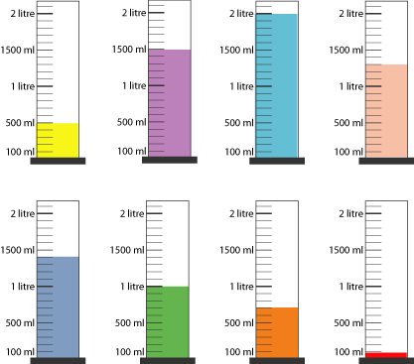
Ahmed had measured out just a thousand millilitres and Belinda twice as much as Ahmed.
Grace had measured out three-quarters of the amount that Belinda had done and Freddie had half the amount that Ahmed had measured out.
Which were their cylinders?
Callum had coloured his water blue. How much did he measure out?
Ellie had coloured her water pink and Dan coloured his orange. How much did they measure out?
"Don't drink that!" Harry had laughed, pointing at Dan's cylinder, "It's not orange juice!" As his hand stretched out, he knocked over his red liquid. "Oh! Harry!" they all wailed again.
How much was left in Harry's cylinder after the accident?
The resource sheet uploaded onto website/attached to email may be of help if you can print it out.

Optional maths for those needing more work
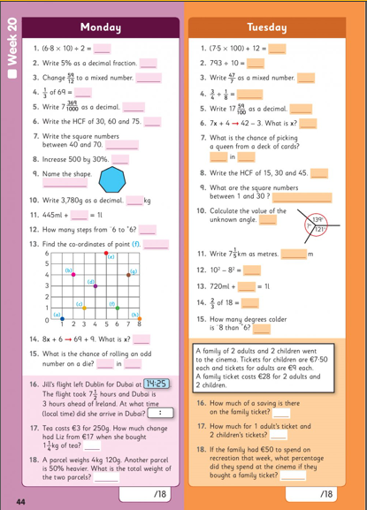

Optional maths for those needing more work

