Hi boys and girls,
We hope you are enjoying the longer days, hopefully the bad weather didn’t dampen your spirits. It is expected to improve again soon. It is great that the country has moved to phase two of reopening, hopefully you can see more of your friends and family now.
Keep up the great work you are doing at home, we have just three full school weeks left in this term. We will be doing more active activities for these final weeks of 5th class so we hope you enjoy them. If you have any fun challenges please share them with us on our padlet pages - we now have one for P.E. and another for STEM. Stay safe and remember to keep your social distance if you are out with friends.
Ms. Nolan, Mr. Costello & Ms. Arnold
SPHE
Water safety is extremely important, especially this time of year. It is very important to go back over water safety rules before the summer holidays. Please read over the rules from IWS ( Irish Water Safety) PAWS programme:
https://watersafety.ie/wp-content/uploads/2019/10/PAWS-4-Presentation.pdf
- Answer some questions to test your knowledge:.
http://paws.edco.ie/fifth-and-sixth-classes/
- Create your very own Water Safety Powerpoint or Google Slide or poster. They can be emailed to your teacher or submitted through Google Classroom. (We will share a blank Google Slide with you on Google Classroom. In the Powerpoint please include safety tips and advice.
- If you have younger siblings or young people around you please take the time to review water safety rules with them.

English:
- D.E.A.R time each day ( 20 mins or more )

- Writing task: Select one of the following
- Word of Advice for the new Junior Infants
- Procedure writing recipe of something you cooked or baked during Covid 19.
- Persuasive language, the first restaurant that should reopen and why it is the most important one.

STEM Challenge
Pick at least one from the list below. Upload a description/ picture or video to our 5th class Stem Padlet page: https://padlet.com/anolan25/nxh5v3bcrqqb79ga
- Design and make a bug hotel for insects.
- Count your heart rate, do some exercise and count it again, is there any difference?
How to measure heart rate: https://youtu.be/tF9-jLZNM10

- Design and make a marble run. You could even create a marble race and get your family/friends involved:
https://www.youtube.com/watch?v=fvrGNgY9_i4

P.E:
Continue to upload your exercise onto our fifth class padlet: https://padlet.com/ccostello37/5dffq48xe52ttk0p
Suggested P.E. activities for this week:
● Create your own obstacle course! Upload pictures/videos or descriptions of course to Padet for others to see!
● Try out some training with GAA legend TJ Reid: https://www.facebook.com/1826850204246158/videos/2327764164195146
● Johnathan Daniels, our celbridge G.A.A coach is conducting online GAA coaching for the next few weeks. Details below on how to register, even if you haven't played before this might be a chance to give it a try in the comfort of your own home!
Online GAA coaching with Celbridge GAA GPO Jonathon Daniels
Microsoft Teams Live Coaching Tuesday @ 10.00am / 11.00am
Register on the form below:
3rd class- 6th class link:
https://forms.office.com/Pages/ResponsePage.aspx?id=hrxFrNSvpUKfwz6H4bd_zuMXttyel3tKqMALl3GWe5lUMFZKQTVDVEtWRk1KQVFMR09JWTJNOFhMTi4u

Maths:
- Mental Maths Wk 35
- Optional Fractions Worksheet:

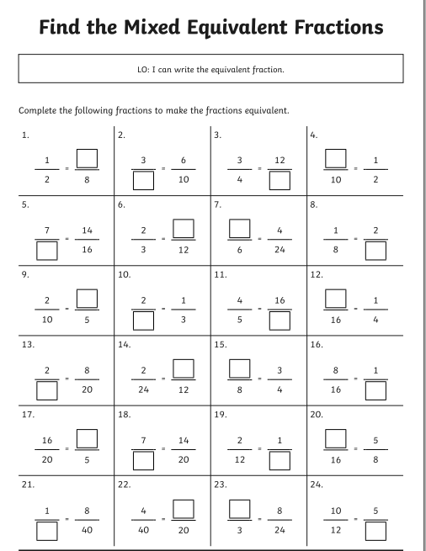
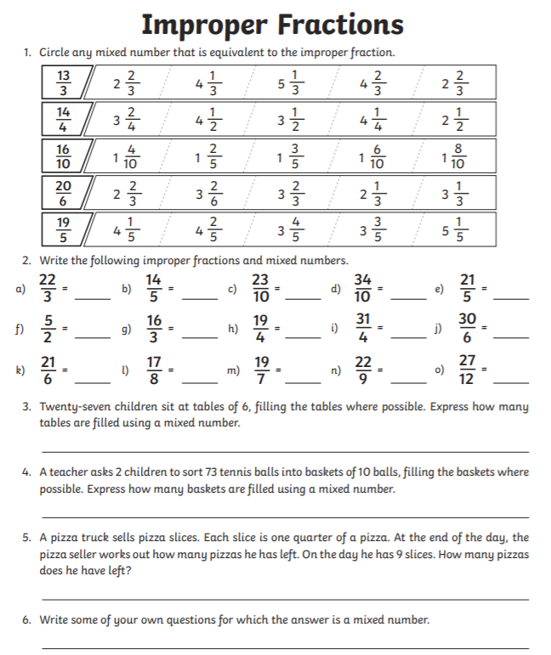
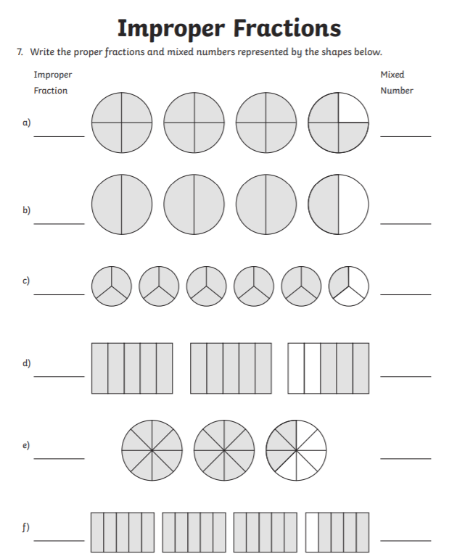

Gaeilge:
