Hi again to all the boys and girls in room 15!
I hope you all had a lovely Easter. I’m sure you are all helping out at home and doing what your parents tell you to do.
I have outlined below the work I’d like you to try for the week beginning April 20th. As I’ve said before, just do your best. If you can’t complete all of the work assigned, pick out the ones that you can do. It might be difficult at home to find a quiet space to do your school work, and I understand that your house may be busy with your parents possibly working from home too.
Remember to wash your hands regularly and to practise good sneeze and cough etiquette. I hope you’re all keeping up the reading! Try and fit in some DEAR time, every day. And remember to get out in the lovely sunshine when you can, practising social distancing of course.
I look forward to seeing you all when the schools re-open.
N. Brennan

Subject | Content | Resources Required
Maths | Money:  Mathemagic  Complete number 2 pg. 141 (Mr. Fang’s restaurant), in your maths copy. Show how you worked out the cost of each meal.  Extra work (optional): pg. 124 (pick 2 or 3 from each number to revise division, with and without remainders)  New Wave Mental Maths Week 27 (including problem solving and Friday tests)  Revise division tables  Play “Daily ten” online or “Hit the button” https://www.topmarks.co.uk/maths-games/daily10  https://www.topmarks.co.uk/maths-games/hit-the-button | Mathemagic  Maths copy  New Wave Mental Maths
English | Jolly Grammar page 52 “ie” sound  Jolly Grammar activities pgs. 52, 53  The object of a sentence is often a noun. It receives the action of the verb. It is the who or what that the subject does something to. The girl played the piano. ( “girl” is the subject and “piano” is the object.)  Reading Zone Unit 25. “Dad, Sam and Blacky”  Answer A in full sentences  B - write the sentence and underline the word you choose with the letter at the end of the sentence.  C – Write full sentence and underline the word you choose.  Narrative writing –write a diary entry for one day this week, or a couple of days if you prefer. Include the day and date of your diary entry..something interesting that happened that day..maybe include a description of a book you’re reading..did you take your dog for a walk..maybe you face-timed your grandparents..include whatever you like to describe your day/days..  Write it in your homework copy, or your English copy if you have it.  Remember to write your diary entry in the past tense.  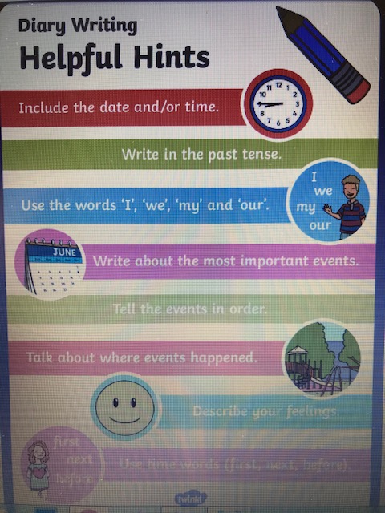  DEAR time every day-your own choice! | Jolly Grammar  Reading Zone  Dictionary  Homework copy/English copy
Gaeilge | Bun go Barr: re-read lch. 82(try your best, you may not know all of the words)  Complete B lch. 83, in your copy. (Try your best)  Complete G lch. 85 (put the items in the correct rooms..in your copies) | Bun go Barr  Irish copy or homework copy
SESE  PE  ART | History:  The Famine: Earthlink Unit 53, read pgs. 118 & 119  Answer the questions pg. 119 in your SESE or homework copy.  Workbook: complete pg. 75  Optional: research more facts about the famine in Ireland in the 1840’s. Record them in bullet point form, add some pictures too!  Science: Earthlink pg 32 + 33 ‘Skin and Hair’  Read and complete questions 1-5. Do these orally, if you find you have too much to do.  If you wish you can draw your own diagram of the surface of the skin under the questions in your copy.  Youtube: PE with Joe Wicks, the body coach  Daily walk/cycle/football or hurling skills practice  -------------------------------------------------------------------  Go outside and pick a spot that you would like to sketch. Spring is in full swing now and the weather is lovely..use pencils or whatever you like. Colour it in if you like!  Optional Work  Optional Work: (You do not have to do this, you can choose do some, all, or none)  History:  Homeschoolhistory – Audio which is great fun and entertaining https://www.bbc.co.uk/programmes/m000hmmf/broadcasts/upcoming  Science:  Virtual Tour of the Natural History Museum in Dublin.  https://www.museum.ie/Natural-History/Exhibitions/Current-Exhibitions/3D-Virtual-Visit-Natural-History Extra challenge: Can you find the Hippo? | Homework copy or SESE copy, if you have it  Homework copy/A4 page/sketch copy..

