Chapter 15-Look Back
Page 63
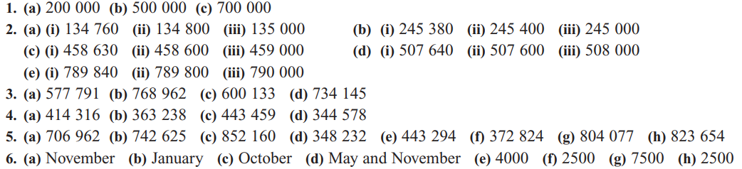
Page 64
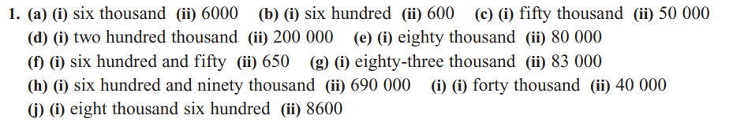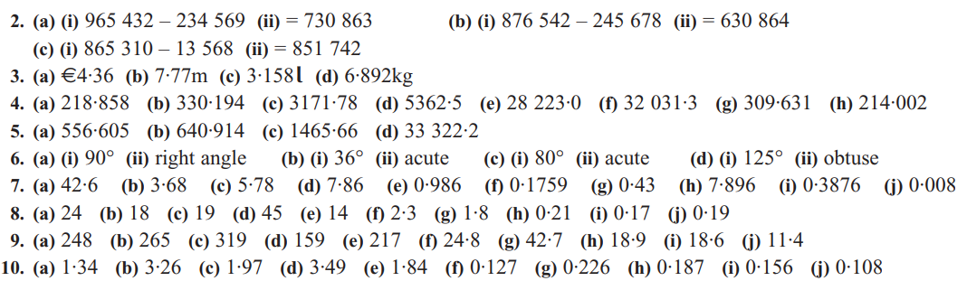

Page 65
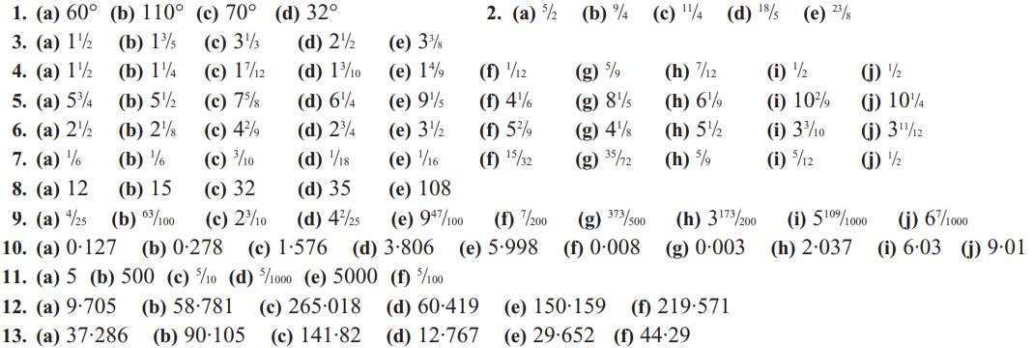
Page 66
