Chapter 22-Mental Strategies 2
Page 95
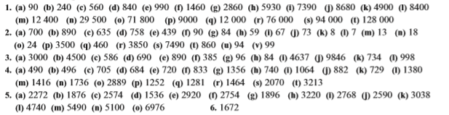
Page 96
