**Chapter 31-Rules and Properties**

**Page 133**

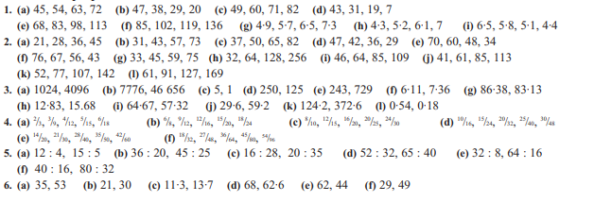

**Page 134**

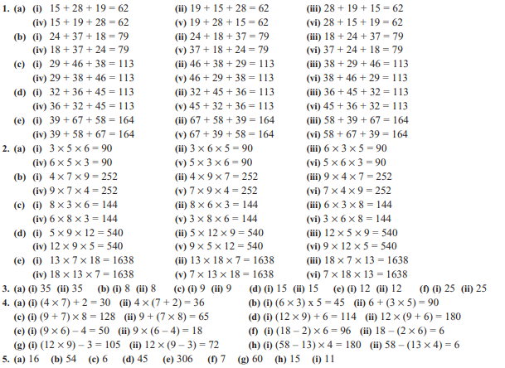

**Page 135**

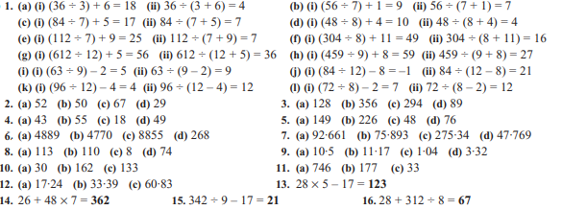

**Page 136**

