Chapter 34, Weight, pgs 143, 144 & 146
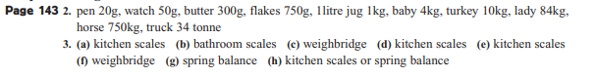
Page 144 1. Your answers will vary. Get someone at home to check your answers as we wont’t
get out to your houses to check these answers .