Cycle Safety-Some Tips on safer cycling
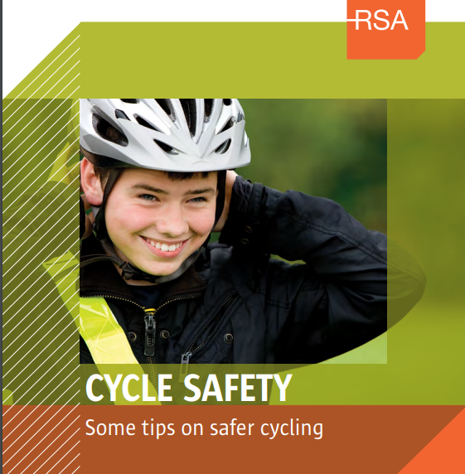
Answers
- Yes.
- 69 to 85%
- 12 years
- No, it is not.
- No, it is not.
- Stop, if it is safe to do so. Never try to race through an intersection when the traffic light shows amber.
- Always look back before you signal.
- Always signal a turn or a change of lane.
- You should leave plenty of space so that if they open their door, they won’t knock you off your bike.
- If your local area provides space to park bicycles, use them.
Never park your bicycle where it could cause problems especially for people with disabilities or on busy footpaths.
Use a strong bicycle lock.

