Cárta Poist

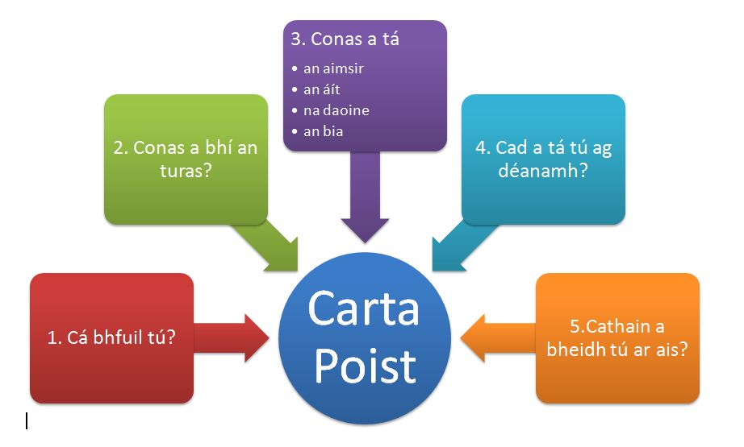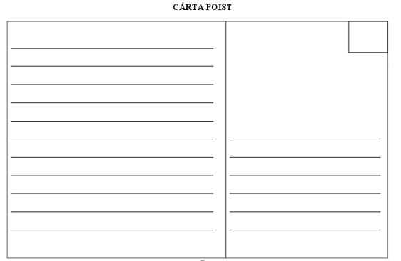

Nathanna Úsáideacha (Useful Phrases)
1. Cá bhfuil tú?  - Tá mé ar saoire i ...  - Tá mé ar thuras scoile anseo i ...  - Tá mé i gcoláiste Gaeilge anseo i ...  - Tá mé ag scríobh chugat ó ...  - Tá mé anseo ar feadh seachtain anois | = Where are you?  - = I am on holiday in ...  - = I am on a school tour in ...  - = I am in Irish college in ...  - = I am writing to you from ...  - = I'm here for a week now
2. Conas a bhí an turas?  Tháinig mé - sa charr - ar an mbus - ar eitleán - ar traein - ar mbád Bhí an turas - ceart go leor - go maith - go hiontach - uafásach Bhí mé tuirseach traochta tar éis an turas I came - in the car - on the bus - by plane - by train - by boat The journey was - ok - good - excellent - terrible I was dead tired after the journey | = How was the journey?

3. Conas a tá...  An Aimsir?  Tá an aimsir ar fheabhas  Tá an ghrian ag taitneamh  Tá an ghrian ag scoilteadh na gcloch  Níl scamall sa spéir  Tá mé marbh ag an teas  Tá mé cosúil le tráta | = How is ...  The Weather?  = The weather is brilliant  = The sun is shining  = The sun is splitting the stones  = There isn't a cloud in the sky  = I am dead with the heat  = I am like a tomato
Níl an aimsir go maith  Tá sé ag cur sneachta  Tá sé ag stealladh báistí  Tá mé préachta leis an bhfuacht  Tá toirneach agus tintreach ann  Tá sé stoirmiúil |  | = The weather isn't good  = It's snowing  = It's lashing rain  = I'm frozen with the cold  = There's thunder and lightening  = It's stormy

An Áit?  Tá mé anseo...  - i Sligeach  - sa Fhrainc  - sa Spáinn  Beannachtaí ón bhFhrainc!  Tá an áit go hálainn  Tá mé ag fanacht...  - in óstán  - i dteach  - in ionad campála |  | The Place?  I'm here...  - in Sligo  - in France  - in Spain  Greetings from France!  The place is lovely  I'm staying...  - in a hotel  - in a house  - in a campsite | 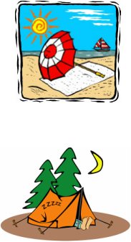
Na Daoine?  Tá gach duine an-cháirdiúil  Tá na daoine go deas  Bhuail mé le buachaill ar an trá  Bhuail mé le cailín sa dioscó  Bíonn an-chraic againn | The People?  = Everyone is very friendly  = The people are lovely  = I met a boy on the beach  = I met a girl at the disco  = We have good fun

An Bia?  Tá an bia blasta  D'ith mé sceallóga agus sicín  Ní maith liom an bia anseo  Tá an bia difriúil | The Food?  = The food is tasty  = I ate chips and chicken  = I don't like the food here  = The food is different

4. Cad a tá tú ag déanamh? = What are you doing?
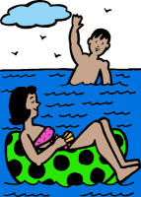 | Tá a lán le déanamh anseo  Níl aon rud le déanamh anseo  Téim go dtí an trá gach lá  Cathaim an t-am ag luí faoin ngrian  Téim ag snámh san fharraige  Téim ag siúl sna sléibhte  Thug mé cuairt ar mhúsaem  Chuaigh mé ag siopadóireacht sa bhaile mór  Cheannaigh mé mála nua agus t-léine duit! | = There are loads of things to do here  = There's nothing to do here  = I go to the beach every day  = I spend the time lying in the sun  = I go swimming in the sea  = I go walking in the mountains  = I visited a museum  = I went shopping in the town  = I bought a new bag and t-shirt for you!

5. Cathain a bheidh tú ar ais? = When will you be back?
Beidh mé ar ais...  - an seachtain seo chugainn  - Dé Luain seo chugainn  Feicfidh mé thú ansin  Go dtí sin, slán | I will be back...  - next week  - next Monday  I will see you then Until then, bye

