Essay Competition Information for Teachers and Parents
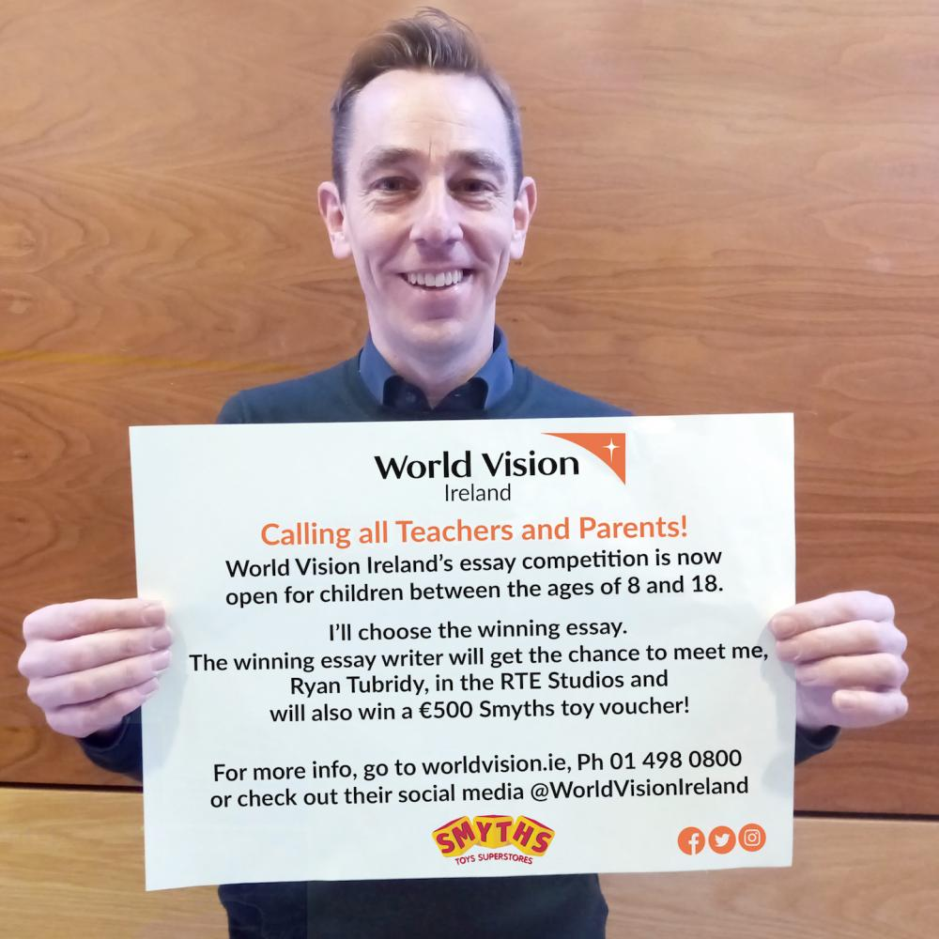
World Vision Ireland’s Climate Change essay competition 2020, for children between the ages of 8 and 18.
Please note that our deadline has been extended to the 30th of April 2020
The essay entries should be sent, with the €2 application fee (€2 per essay entry) to:
Essay competition,
World Vision Ireland,
The Mews,
Garland House,
Rathmines Park,
Dublin 6.
or you can pay online by filling out the transaction form below and email your essays to ireland@wveu.org,
The entries will be narrowed down to the final 10, and celebrity judge Ryan Tubridy will choose the winning essay.
The winning essay writer will get the chance to meet Ryan Tubridy in the RTE Studios and will also win a €500 Smyths toy voucher.
Download a poster for your notice boards here

Instructions:
- Write an essay entitled ‘How We Can Save Our Planet’.
- Word count is 800 words or less.
- Entry cost is €2 per essay, per child. (Not per class. For example, if there are 10 entries, €20 will need to be submitted with the entries, to cover the €2 per essay entry fees). Cash, cheques and postal orders are all accepted. Alternatively, payments can be made online by filling out the form below.
*Please ensure to include your school’s details on the online payment transaction form, so that when the essays arrive by post, we will know that the entry fees have been paid.
- Children should write their name, age and school address on the top corner of the essay, and hand it to their teacher.
- Teachers should put the essay entries, along with the entry fee, into an envelope and post the essays to: Essay competition, World Vision Ireland, The Mews, Garland House, Rathmines Park, Dublin 6.
- All proceeds will go to World Vision Ireland, a child-focused international humanitarian aid charity.
- The school of the winning essay will be contacted directly by World Vision Ireland.
- Due to the number of entries, feedback cannot be given on essays.

Essay competition form

