Fifth class work at home March 2020
Children are to complete all work in the yellow copy, Red Copy in room 20

We understand that all children work at different paces and have different circumstances. If you feel this is too much work for your child or the work is too difficult, prioritise the reading and select what they can do.

Guidelines:
We recommend that children spend on average per day:
- English: 50minutes to include at least 20minutes reading.
- Irish: 40 minutes
- Maths: 50minutes (to include revision of Fractions/Decimals/Percentages, tables and mental maths)
- History/Geography: pick one per day and spend 40 minutes.
- P.E: Minimum of 10 minutes a day/ an hour per week.
- Additional reading is also encouraged.
- Corrections for maths & mental maths will be uploaded each Friday to self correct.

Maths: Books needed: Operation maths/ Mental Maths

- Mental maths per day, follow on from previous week!
Corrections will be available for the first week (week 25 for R.21 or Week 24 for R.19) on friday 20th
Room 20 should complete Thursday and Friday review on Friday 13th of March. They should complete the next week's 5 days Mental Maths from Wednesday 18th of March to Friday 20th of March. They should complete the following week of mental maths on the week starting Monday 23nd of March.

Recommended: 16th-20th March 2020. Length:
- Converting centimeters to millimeter and vice versa (pg 121)
- Select appropriate measuring tool (pg 122)
- Problem solving (pg 123 - work it out)
- Finding the perimeter of a shape (pg 124-125)
Answers for these questions will be available on Friday 20th.

Recommended: 23rd-27th march 2020:
Weight:
- Selecting appropriate instrument of measurement (pg 148 Q1) (pg 149 work it out & Q3)
- Converting grams and kilograms in fractional and decimal form (pg 150/151 Q1/2/3/4/ Work it out)

Answers for these questions will be available on Friday 27th March

Revise fractions/decimals/percentages + Tables

English: Work through this work at your own speed, prioritising the reading!

Books needed: Reading Zone/Class Novel/ Dictionary/ English copy
Novel ( class depending) (R.21 -Charlotte's web) (R.19 Danny the Champion of the world)
- Reading (Charlotte's web- pg 42-65 chpt 6-9 16th-20th March, updated next week) (R.19 two chapters per day)
- Reading Novel Room 20. Read a chapter per school. So Chapter 1 Hunger on Friday 13th. Chapter 2 Under the Hawthorn Tree Wednesday 18th of March. Boys and girls should continue with this for any school days that schools are closed for. After each chapter children should have half a page summary and half a page illustration based on the chapter as outlined below.
- Chapter summaries. (For each chapter start at beginning)
- Wordbank ( of new words per chapter you read)
- Character profile (two per week) (Include: reason why you like or dislike character, description of their appearance, and three traits backed up with evidence from the text, use paragraphs)
- Illustrations per chapter

Reading Zone:
- Unit 17 Read & answer questions A-E & G your choice of the two (creative writing)
- Unit 18 Read & answer questions A-F

Gaeilge:
Books needed: Bun Go Barr.
- Scríobh sceal faoi lá fhéile phadraig an bhlian seo chaite. (Write a story about St. Patricks day) ( banna ceoil- music band, paráid- parade, seamróg- shamrock, Flóta- float, nathair-snake, leipreachán- Leapracan, ag rince- dancing, bratach- flag, lár na cathrach- city centre)
Sampla:
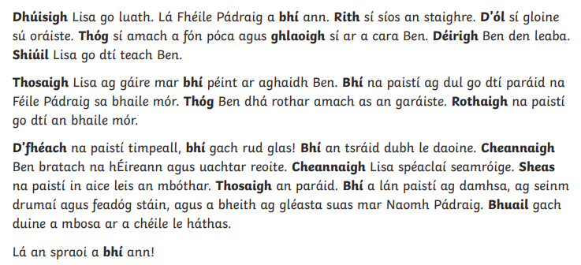

- Bun Go Barr lch 124 Amandán Aibreáin
Focal nua: (Amadán - fool, cleas ullamh - jokes prepared, ar bís- excited, iall do bhróige- laces on your shoes, Phléasc- burst, damhán alla- spider, scread- scream, olagón- wailing, sall- over to, léitheoireacht agus scríobhneoireact- reading and writing, stair- history, cothrom- fair, í fós- her still, n-athraíonn mé m’aigne- before i change my mind)
- Bun Go Barr: lch 126/127 B/C/D. Lch. 129 I. (Write in copy)

History:
Books needed : Small world History & Geography + copies
- Unit 12: Feasts and Festivals (Small World History pg 58) Read 58-60 A-C, D (3)

Geography/Science:
- Unit 12: Communication (Small World Geog/Science read; pg 67)
- Activity: Write a blog on a subject ( for example, fashion, league scores/performance of a team/ How to best use your free time etc)

Other:
P.E: Ten at Ten videos available online ( recommend 1 per day) https://rtejr.rte.ie/10at10/
Websites

