Instructions:
Listen to the sound file 3 times and try your best to answer these questions:
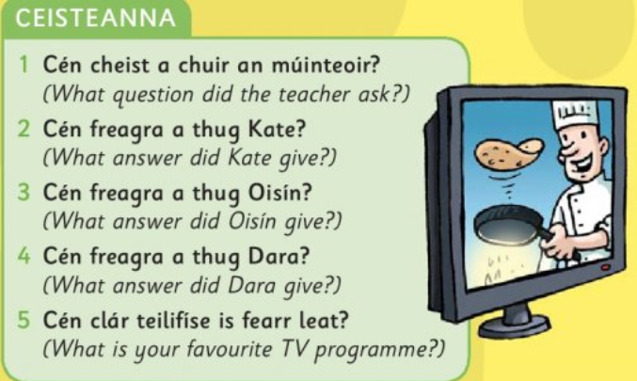
Some helpful vocabulary:
