Question | Answer
1 | 143 and 256
2 | 318
3 | 421
4 | 395
5 | 685
6 | 815

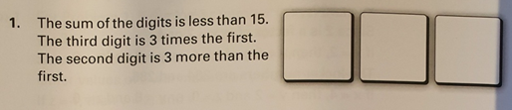
The sum of the digits is less than 15
The third digit is 3 times the first - this means the Hundreds digits are 1, 2 or 3
units digit is either 3, 6 or 9
The second digit is 3 more than the first so digit 2 would be 4, 5 or 6
Giving three possibilities so far: 143 256 or 369
We can rule out 369 as the digits total 18 leaving only 2 possible solutions
143 and 256

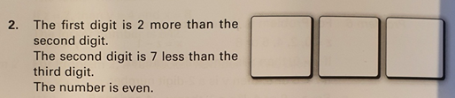
For this one we know the number is even, it therefore must end in 0,2,4,6 or 8
Given the 2nd digit is 7 less than the third we know the third digit must be 8
If the 2nd digit is 7 less than 8 it has to be 1, meaning the first digit is 1 + 2 = 3
So our only answer here is 318

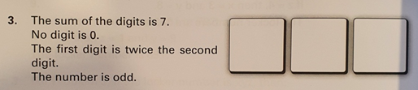
Firstly if the number is odd I know the third digit must be 1,3,5,7,or 9. We can rule out 9,7 and 5 straight away and they are too large to give a sum of 7 for all three digits.
The first digit is twice the second digit meaning that if the first digit is either 2 or 4 (it can’t be any higher as the sum would then be greater than 7) and the 2nd digits would be 1 or 2
Putting that all together if the first digit is 2 the second is 1 and the third digit is must be 4 to equal to 7 but the third number must be odd so this combination must be ruled out.
Our only other option is the first digit is 4 the second is 2 and the third digit is 1 our number 421 when added equals to 7.

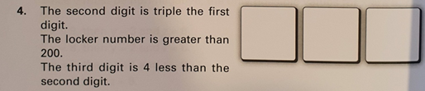
The locker number is greater than 200, this means that our first digits can be 2,3,4,5,6,7,8 or 9
We can rule out 4,5,6,7,8 and 9 for the first digit as when they are tripled they become 2 digit numbers.
The second digit is triple the first meaning the second digit is either 6 or 9
The third digit is 4 less than the second meaning it is 2 or 5 (it rules 3 out of being a possibility for the second digit)
So our possibilities are: 262 – there is only one number two so this can be ruled out giving an
only possible answer of: 395
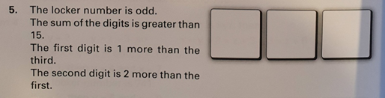
The locker number is odd meaning digit three must be 1,3,5,7 or 9
The first digit is 1 more than the third meaning we can rule out 9 for digit 3.
The second digit is 2 more than the first meaning we can rule out 7 for the final digit.
So lets try out the various options using a table :
Digit 1 (H) | Digit 2 (T) | Digit 3(U) | Sum >15 | Possible  Y or N
2 | 4 | 1 | X | N
4 | 6 | 3 | X | N
6 | 8 | 5 | Y | Y
Our only answer option is 685

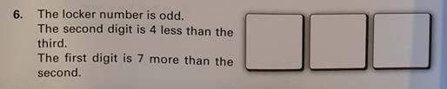
Once again our locker number is odd so the third digit must be 1,3,5,7 or 9
The second digit is 4 less than the third meaning we can rule out 1 and 3 for the third digit, and our only options for digit two are: 1,3 or 5
The first digit is 7 more than the second digit meaning the second digit can only be 1
Our answer is therefore: 815

