The Plain Indians

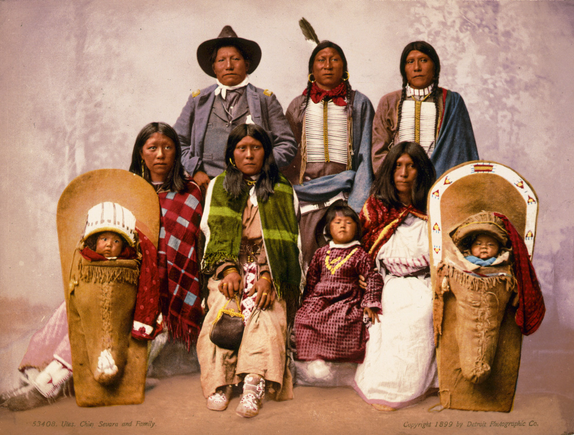

By Katie O’Connor

Native Americans
The Tribe that I am doing my project on is the Plain Indians. They lived on the Great Plains of North American. For my project I am going to do:
- Food
- Homes
- Clothes
- Family Life

.

By: Katie O Connor

Food
Native Americans hunted for their food. They hunted for the buffalo. The buffalo was very important to them. They called the buffalo bison. They also ate corn which they called maize and they also ate squash, pumpkin, cotton and potatoes. They also hunted deer, ducks, rabbits, and other animals for their food. Tobacco, sunflower, plums and other wild plants were gathered in the wild.
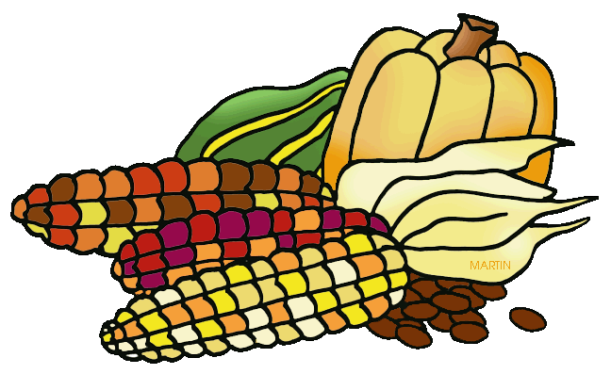
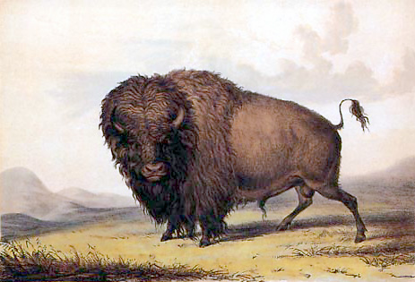
Homes
Tepees where the homes where the Plain Indians lived. A tepee was build using a number of long poles as the frame. The poles were tied together at the top and spread out at the bottom. The outside of the tepee is wrapped in buffalo hide. When the Plain Indians moved place to place the woman of the family would set up and build the tepee. Building a tepee is very basic and easy it only takes around 30 minutes to build. In the summer they make a gap at the bottom of the tepee to let the cool air come inside and keep the place cooled. In the winter they use grass to keep the tepee warm and in the centre of the tepee a fire would be build. There was whole at the top to let out the smoke so the tepee wouldn’t go all foggy. They used buffalo hides for their beds and blankets to keep their homes warm.
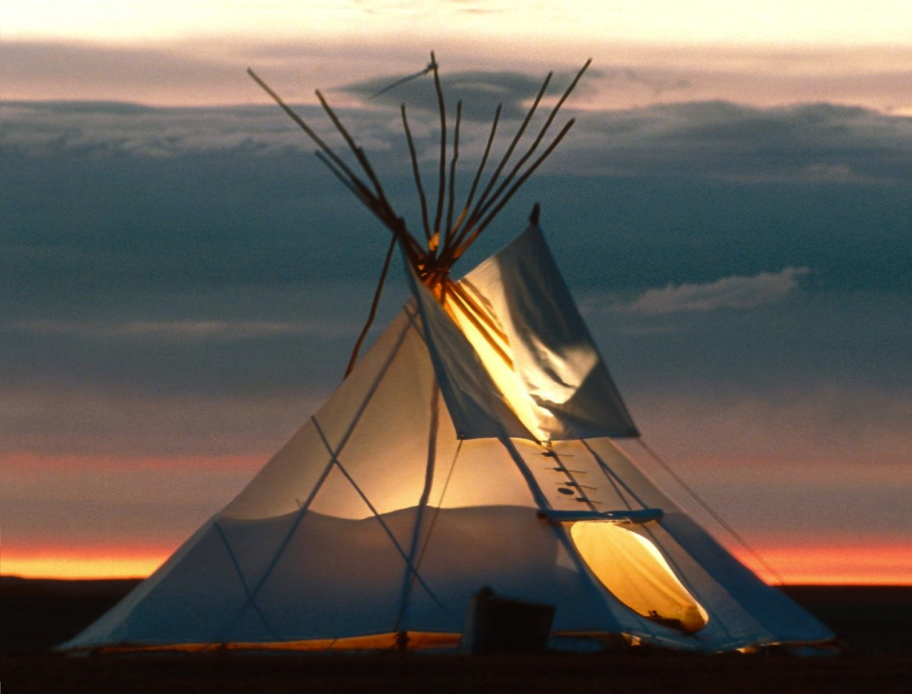

Clothes
The material used by the Plain Indians in their clothing was made from animal hides. Generally they used the hides of the animal they hunted for food. The Plain Indians used the buffalo skin for their clothes. All of their clothes were made by hand. The woman would generally make the clothes. First they would tan the animal skin. Tanning is a process that would turn the animal skin into leather which would last a long time and not decompose. Then they would need to cut and sew the leather into a piece of clothing. Most Plain Indian men wore a breechcloth. This was a piece of material that they tucked into a belt that would cover the front and back. In many areas, especially areas with warm weather, this was all men wore. In cooler weather, and in winter, the men would wear leggings to cover up and keep their legs warm. Many men went shirtless throughout most of the year, only wearing cloaks when it got very cold. The Plain Indian woman wore shirts and leggings. Often they wore shirts or tunics as well. Most of them wore some sort of footwear. This was usually a shoe made of soft leather called a moccasin. When the Europeans came some of the Indian tribes were forced to meet up. They began to see how others dressed and took the ideas that they liked.
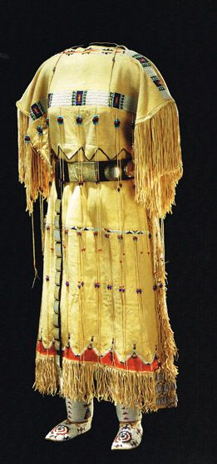zz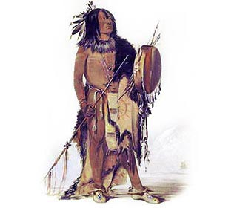
Family life
The Plain Indians had to hunt, farm, prepare food for the winter, build homes, make their own clothes, and protect themselves from enemies. The work was divided between the men and the woman. They each took different roles in their daily lives. The men and the woman’s work were very similar. The women were responsible for work around the house like cooking and raising the children. The men were responsible for the work outside the house like hunting and raiding. The women were generally in charge of the home and sometimes the field. The women cooked and prepared the meals. This could involve skinning and cleaning the animals, gathering fruit and nuts, building a fire, and smoking meat to be stored for the winter. Women had a variety of crafting skills they use around the home including making baskets, weaving cloth, preparing animal hides, and making clothes. The women were responsible for harvesting the crops. The men might help in this task, but it generally fell upon the women. Women had a Varity of other jobs including raising the children and gathering firewood. When they moved it was generally the women’s job to pack up the home for moving and then set it back up at the new location.
The men were in charge of the jobs away from home. The men’s main job was hunting and fishing. Animals were not only used for food but they were used clothes and in some cases to make the homes. Men also were responsible for making war and protecting the village. Typical men’s craft had to do with their job such as weapons for hunting and boats for fishing and travelling. In most Native American tribes men were the political and religious leaders. They often did the heavy work such as building permanent homes and planting crops. Young children and babies stay close to their mother. The mother goes about her daily work and chores carrying the baby on her back in cradleboards. The mother often nursed the child until it was 2 or 3 years old. New children were generally treated as special and many tribes had ceremonies they performed on newborns. Naming a newborn was a very important process. A person’s birth name was usually not used in an everyday conversation. People referred to each other by their relationship or by a nickname. Boys were often given a nickname that described a characteristic or exploit of the boy. The boys followed the men around and were taught how to hunt and do men’s chores. The girls followed the women around and learned the traditional women’s work like making baskets, working the fields and cooking. Children learned through stories told by the elders. These stories were not only entertaining but also held the meaning and taught the children how they were expected to behave