Good morning boys and girls,
I hope you are all keeping safe and healthy and getting out in the beautiful sunshine we have been treated to this week. Summer has definitely arrived!
Thank you very much for all the artwork, stories, maths and other assigned work I received last week. It’s great to see the effort you’re all making. Keep up the neat handwriting, good spellings and punctuation. Also, make sure you’re ruling your page, as practised in class. Remember to self-correct your work each week also. Answers are put up on the website, each Friday.
Continue to send on your work to me.
This week I would like you all to choose from 2 of the following to send onto me, either through Google Classroom or by email.
- County fact-file 2. Artwork for this week 3. Poetry-writing
I look forward to receiving 2 of the above from you. You can also send on the 3rd option, when it’s completed, if you like.
Remember to keep washing your hands and practising good cough and sneeze etiquette.
N. Brennan
Subject | Content | Resources
Maths | Mathemagic : Topic..Multiplication/Time  Page 146 Q. 1-3 orally  (We have spoken in class about multiplying by ten and how it means to move all the digits over by one space in our place value – some people refer to this as simply adding a zero)  Write out the answers to Q 4 into your copy. Estimating. (You are rounding each number to the nearest 10.  Example: 84 x 7 = 80 x 10 = 800)  Page 147 Q 2-3 Write out the sums into your maths copy with answers. (A good revision of your tables)  Page 149 Q 1-4 (Please see attached video on how to complete these sums)  New Wave Mental Maths Week 30 Page 86 and 87  Revise division tables  Play “Daily ten” online or “Hit the button”  Additional resources and challenges included in this document:  Maths puzzles – Time riddles and additional challenges on Time. | Mathemagic  Maths copy  New Wave Mental Maths
English | Jolly Grammar page 58 <au> <aw> <al> sound  (See attached teaching notes)  Jolly Grammar activities pg 59 (homophones: are/our)  Remember when parsing:  Nouns = black, verbs = red,  Adverbs = orange, pronouns = pink, adjectives= blue  Prepositions = green, conjunctions = purple  Reading Zone Unit 30 “A Lesson in Sharing”  A - your answers should be in full sentences, remember the reader should know what the question is from your answer.  B – words and letter  C – words only  D – words and letter for answer only  E – write the entire sentence, inserting capitals, full stops or question marks – circle all the changes you made in a different colour, this will make your correcting easier.  Creative writing: Write a poem  Choose any topic you like, it could be your pet, summer, the beach, holidays, lockdown…  Choose what style of poem you’re going to write: An Acrostic or a verse poem. Be as creative as you can. Use adjectives, try a few rhyming words, if you like, but they’re not necessary.  Off you go and be a poet!  Draw a picture to go with your poem. Decorate it if you like, I would love if you all would send me your poems this week. I look forward to reading them.  (Last week, Múinteoir John on School Hub wrote an Acrostic poem about his dog Django..you might have seen it! It was really good)  DEAR a book of your choice | Jolly Grammar  Reading Zone  Dictionary  Homework copy  Tutorial for writing acrostic poems.
Gaeilge | Bun go Barr:  Lth. 106-107 Léigh an scéal  (Listen to the story by double clicking on the mp3 file)  Lth 104 A. Write the full sentence, using the picture clues.  B. Complete the sentences, with the correct verb from the list.
SESE | Geography: County fact-file:  Choose any county in Ireland and write a fact-file about it. Include the following:  - Counties that border it  - Province  - County nickname (if it has one)  - County crest  - Gaa colours  - Famous people from the county  - Landmarks (tourist attractions)  - County town  - Population of the county  - Physical features; mountains, rivers, lakes  - Tourist attractions  - Family connections to the county/reason for choosing  If you like, you can type your fact-file and add in some pictures if you can. Or if it’s easier, write it into your copy. Give each section a heading.  I would like everyone to try and complete this please and send me on your completed county fact-file.
Art | Create your own piece of art in response to the new Banksy art shown below. It depicts a child playing with a Toy nurse and Batman and Superman, the traditional superheroes left in the toy basket.
PE | Youtube: PE with Joe Wicks, the body coach  Daily walk/cycle/football or hurling skills practice
SPHE: | ‘Mindfulness for children’ with Jackie Farrell  Life skills challenge:

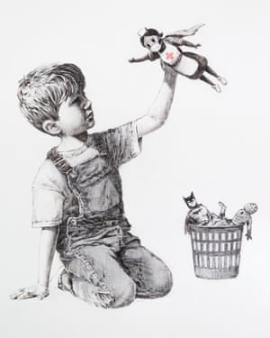

New Banksy piece celebrates superhero health workers

Artwork depicts child playing with nurse toy, with Batman and Spider-Man discarded in a bin

Optional work:
Oral language Activities-
- Allow your child to speak for at least 30 seconds uninterrupted about the picture below using descriptive language., predict what is happening, discuss facial expressions, emotions etc.
- Before, During and After- Allow your child to examine the picture and discuss in detail what he thinks happened before, during and after the photograph was captured.
- Pupil in role- When prompted your child must become the character in the picture and tell exactly how they are feeling. Encourage expression and drama here.
- Nosey nosey- Examine the picture closely. What do you see in the background? Do you notice anything unusual? Is there anything you didn’t see the first time etc.
- Once this is done you may then read the description of the photograph with your child and discuss.

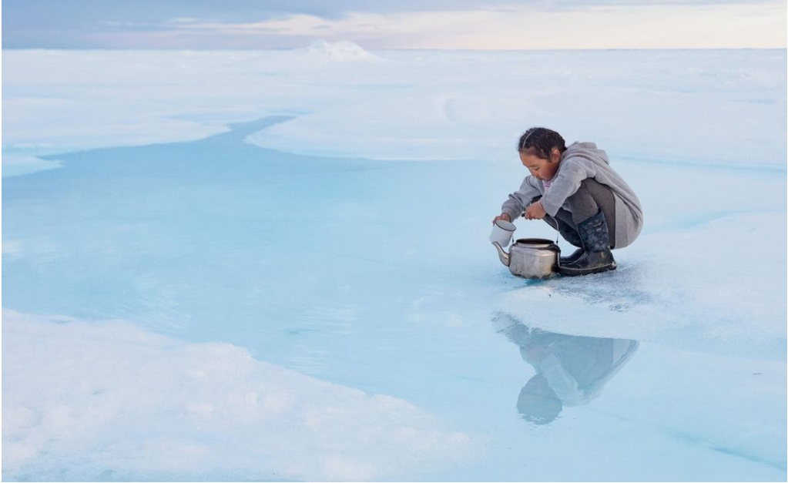
When sea ice ages, the salt sinks into the ocean, leaving fresh, drinkable water on top. Charlotte Naqitaqvik collects a teapot of water at her family’s hunting camp in Nuvukutaak, near the community of Arctic Bay in northern Canada.

Jolly Grammar Teaching Notes
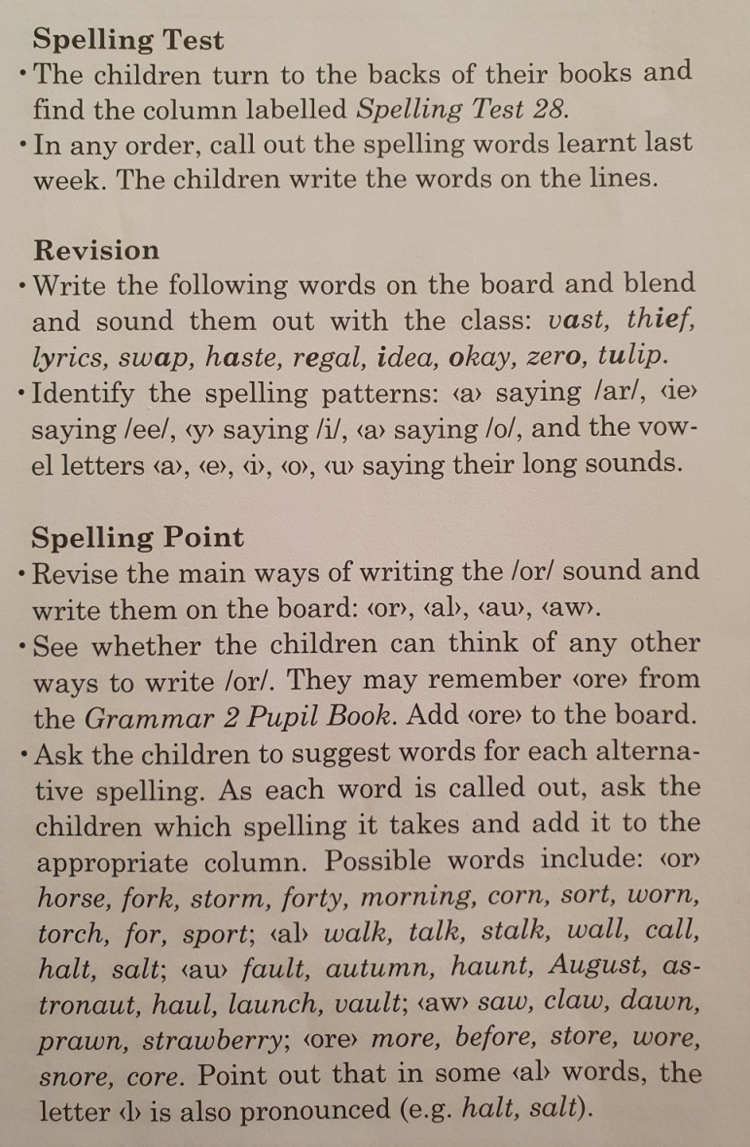  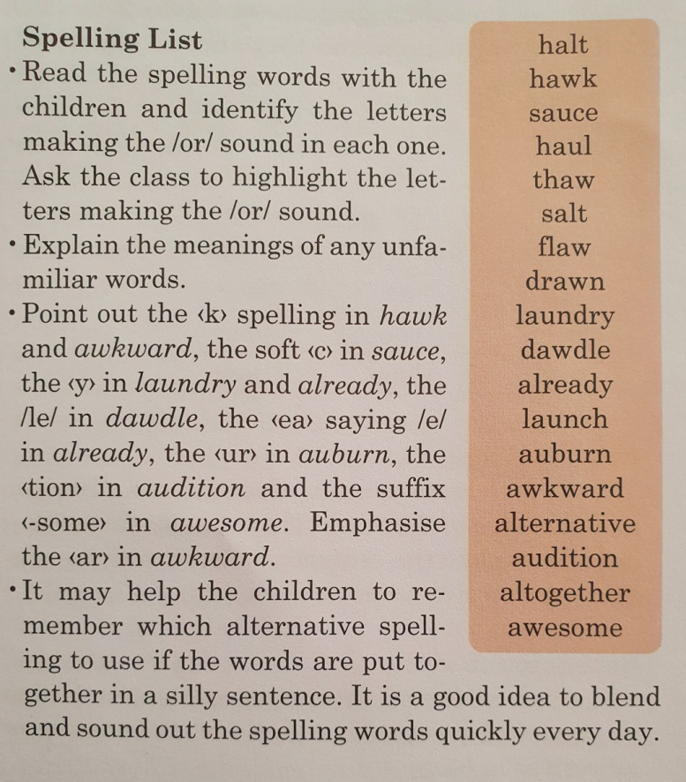 | 