Notes for correction of Jolly Grammer:
Bottom of page 56:
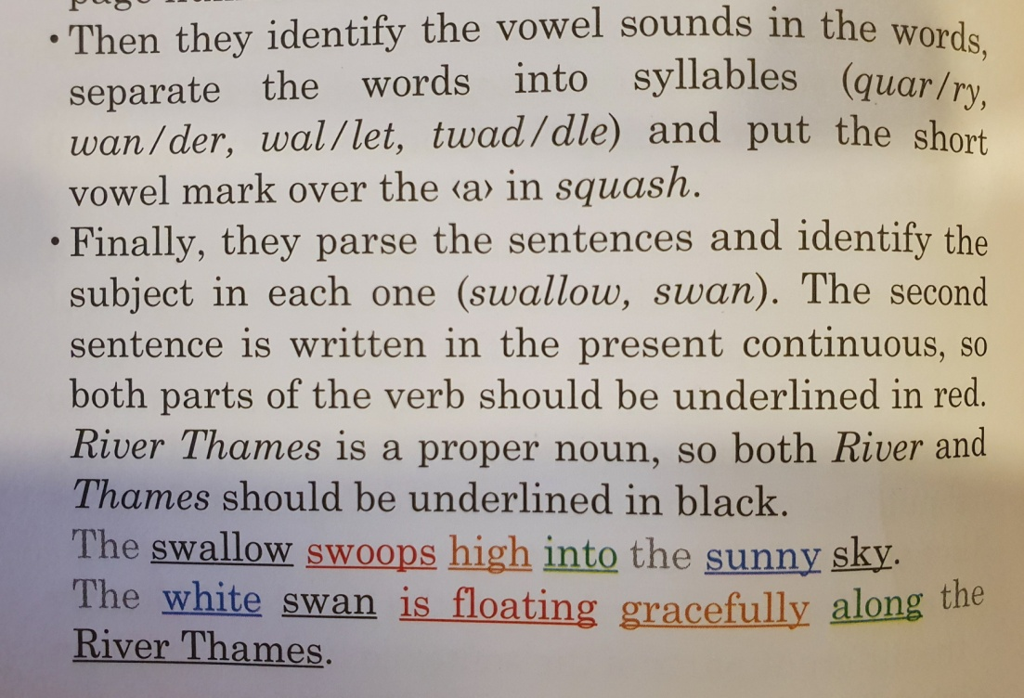
Page 57:
It is mine. (hat)
It is ours. (book)
It is his. (coat)
It is yours. (teddy)
It is yours. (dog)
It is theirs. (cat)
It is hers. (brush)

