Oh! Harry!

Age 7 to 11

Referring to the clues given, the first thing I looked at was Ahmed's because it gives the exact amount which is thousand millilitres. According to that number I can use it to find out the rest of the numbers.
It is said that Belinda's amount is twice as Ahmed's so it equals 2000 millilitres.
Grace measured three quarters of the amount Belinda has. Then the amount will be 1500 millilitres.
The next clue is that Freddie has half of the amount Ahmed has.
There are other clues as well and one says Callum's is blue. There are two blues but because Belinda has the light blue so Callum must have the darker blue. Answer: 1400ml
Another one was that Ellie's is pink and Dan's is orange. Answer: Ellie-1300ml, Dan-700ml - together 2000ml
For the last question I wonder if the picture showed the measure after the accident or not. If it is, the answer would be 100ml, if not it can be zero or other numbers.
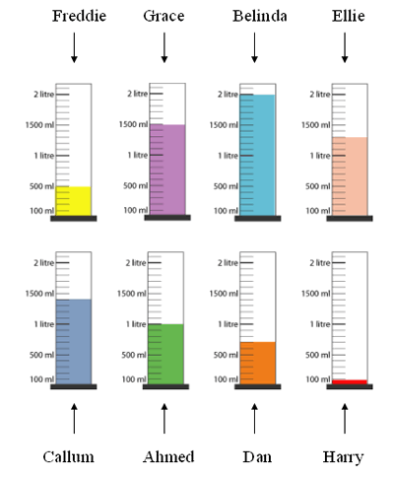
It's a good point about Harry's cylinder. We don't know whether the picture shows the amount before or after the accident, so your answer will depend on what you assumed.

