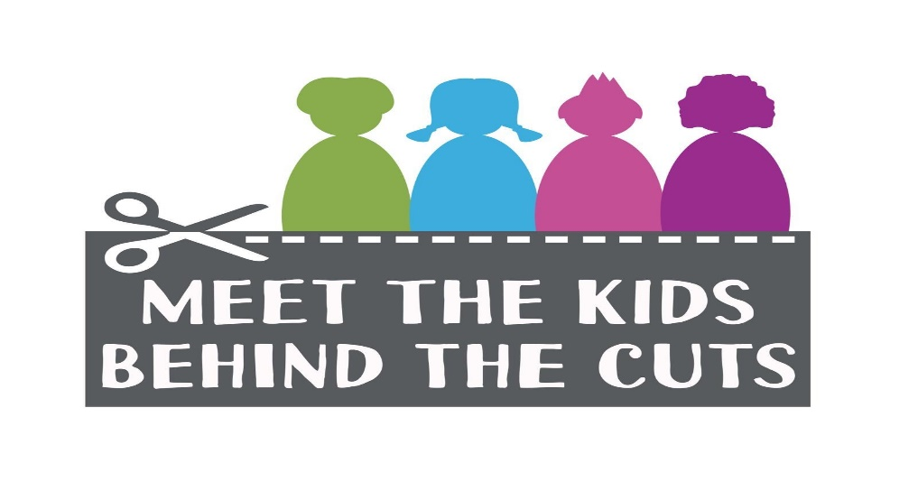
Briefing Document
- Problems with Ireland’s current model of inclusive education –
Not enough resources in either special schools or mainstream schools for pupils who need them.
Not enough special school places for children who need them.
Not enough special unit places for children who need them.
Not enough special class places for children who need them.

- Possible solutions to these problems –
Provide enough resources in either special schools or mainstream schools for pupils who need them.
Provide enough special school places for children who need them.
Provide enough special unit places for children who need them.
Provide enough special class places for children who need them.
Provide enough resources in either special schools or mainstream schools for pupils who need them.

- Specific Problems
This government :
- Leads the public to believe that mainstream schools are refusing to take children with special/additional needs rather than acknowledge that the government has not put the infrastructure and resources in place for these children. Resources and infrastructure do not meet the needs.
- Budgeted for 800 posts (school year 2019/2020) Special Needs Assistants (SNA) posts when the number of SNA posts needed is far greater. Number of SNA posts do not meet the needs.
- Informs parents and pre-schools that your child no longer needs a diagnosis/label as the mainstream primary schools have an adequate amount of resources to meet your child’s needs when the reality is the resources available to schools do not meet the needs of the children in the schools. Resources in mainstream schools do not meet the needs of the children.
- Instructs HSE to direct parents back to schools for psychological assessment in an effort to reduce the chronic HSE waiting lists. The National Educational Psychological Services (NEPS) allocation to schools in no way meets the needs of children around Ireland. NEPS allocations do not meet the needs.
- Instructs HSE to give interventions and strategies to parents and school staff rather than work directly with the children i.e. expect parents, teachers and SNAs to deliver speech and language/ behavioural /psychological etc. programmes in place of trained professionals. Number of HSE professionals (Speech and Language Therapists, Occupational Therapists, Psychologists, Psychiatrists) does not meet the needs.
- Proposes the removal of the right of a school to ask about the needs of a child on enrolment. Schools will not able to inform the National Council of Special Education (NCSE) and the Department of Education and Skills (DES) of the needs of the school. Resources will not match the needs.

- What does under-resourcing and cuts actually mean for those involved?
Children are not guaranteed their right to be ‘treated equally’. All children should have equal access to education and this is not available to them when there are not differentiated appropriately for by the state.

Under-resourcing and cuts impact all children's wellbeing. Learning outcomes are reduced. Children’s self-esteem is affected by inadequate support.

For children with additional needs, shared access means an SNA may not be in the room when required leading to safety concerns, communication difficulties, emotional and behavioural challenges, reduced learning outcomes. Shared access means an SNA may not be available to them in yard when the child needs them to help identify and solve social conflict, find resolution to friendship problems, ensure their physical safety in a very busy environment.

Children who are most in need do not have access to HSE professionals to work directly with them e.g. psychologists etc. Teachers are expected to take on the role of the SNA, the Speech and Language Therapist, Occupational Therapist, psychologist etc. which reduces capacity to teach effectively. Differentiation in class requires additional time to prepare extra resources. Teachers’ workload is increasing as the widening levels within classes often necessitate a different programme for many children. As a result, all children have reduced access to direct teacher contact, leading to reduced attainments.

- Proposals by the NCSE and the government will create more problems:
The General Allocation Model (GAM) for SNA support is part of the new School Inclusion Model (SIM).
The Department of Education and Skills (DES) and National Council for Special Education (NCSE) plan to introduce a General Allocation Model (GAM) for SNA support in September 2020. The allocation will be based on each school’s current allocation. Schools have been informed that they will be forced to appeal if their allocation is insufficient.
Problems with the proposed GAM for SNAs/SIM
- Currently, there not enough SNAs in the system to match the needs.
- The proposed GAM for SNAs/SIM cannot match the needs going forward, given that current needs are not being met.

- The NCSE cannot know what number of SNAs is sufficient when schools are no longer to apply and parents are not to get a diagnosis.
- By telling parents they no longer need a diagnosis or label (introduced to cut HSE waiting lists), they have taken away the parent and school’s ability to properly quantify and qualify the needs of the child.

- The appeals process is not fit for purpose.
- Based on school figures we have gathered to date, of the 129 reapplications, appeals and new applications made since May 2019, only 4 applications or appeals have been successful with 0.5 of an SNA post being granted equating to just 0.125 per application.
4. SNAs are being allocated by budget rather than by need.
- The DES / NCSE gave an allocation of 800 SNAs for this school year 2019-2010. 800 SNAs does not match the needs for this school year. NCSE website states they process 20,000 applications.

- The DES / NCSE have announced an allocation of 1,064 SNA posts for 2020-2021. This is a mere 264 additional posts to the 2019-2020 allocation – which we know is insufficient. How can this guesswork figure be enough to meet the needs for 2020-2021 when the number of children enrolling in schools for 2020-2021 is increasing?
The NCSE is in disarray and not available to support schools or families.
By taking away a child’s right to receive a diagnosis, they also take away the child’s right to understand their needs, why they are the way they are. This will have a huge effect on their mental health as they grow up in a system that does not care about them.
We call on NCSE and the DES to have meaningful consultation with schools, parents and children’s advocacy groups to inform the right SNA support model for every child.
- The School Inclusion Model
The NCSE advise putting all children, regardless of need, in the same ‘local’ school and place all the resources there. This model of inclusive education is based on the New Brunswick Model. New Brunswick is a province in Canada with one tenth of the pupil population of Ireland.
While this model sounds good in theory, it has many critics including parents and teachers. The proposed model will save money but it will take away options for children and parents.
What would the proposed model of inclusion look like?
Every child in a mainstream classroom has needs. Some of these needs are occasional or intermittent while others are constant. Some needs are physical while others are social/emotional. If the necessary resources are available, all the children can achieve at their own level.
The proposed model places children who would usually attend a special school, unit or class in the ‘local’ mainstream school.
The proposed model places children with high sensory needs who are non-verbal and cannot cope with the noise level of a mainstream classroom, children who are verbal with high medical needs, children with dyslexia, children with physical and toileting needs and the children with typical needs being educated in the same classroom. This might seem ideal if the right amount of resources were put in place but the mainstream classroom does not suit every child.
Some children cannot cope with bright lights, others cannot deal with the noise, while others cannot explain to the adults what their needs are and become very agitated and upset. The mainstream classroom can be a very upsetting place for these children.
If the school cannot ask about the needs of children being enrolled, there could be any number of children with varying degrees of needs in one classroom. Principals/teachers would only know the needs of the class on the first day of school in September - in Junior Infants and other classes where a place became available.
We call on NCSE and the DES to have meaningful consultation with schools, parents and children’s advocacy groups to inform the right inclusion model for every child.
- Other relevant factors to consider
Currently in Ireland there is very little training given to student teachers. If you wish to receive training in special education, you must first be employed in a special education setting. How will teachers manage the needs of a diverse classroom without training?
School resources e.g. SNA access, are informed by budget rather than needs. The DES gives the NCSE an allocation of SNAs for the following year and the NCSE allocate them as they see fit. The number of SNA posts made available do not match the needs of the children or the schools.
The NCSE advised frontloading the SNA scheme and introduced a continuum of support for children with special/additional needs. The main objective is to make the child ‘independent’ of the SNA regardless of educational attainment. i.e. once the child can sit quietly, SNA access will be unavailable to them.
Are we to accept the marginalisation of children under the banner of ‘inclusion’?

