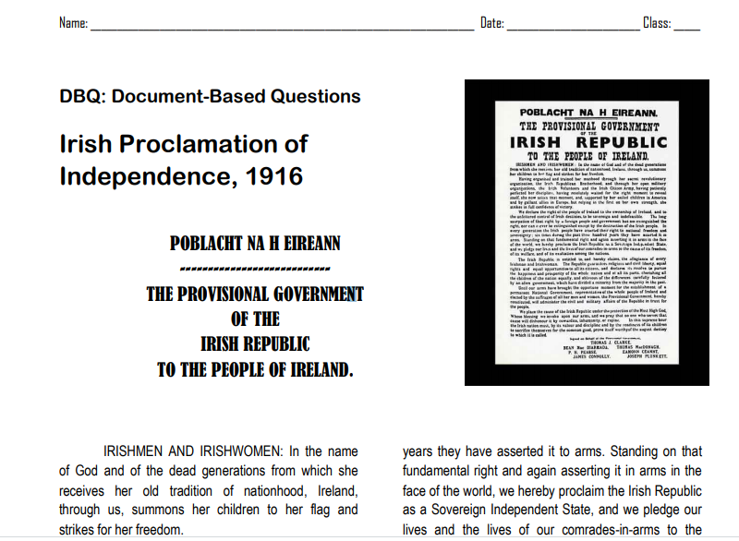
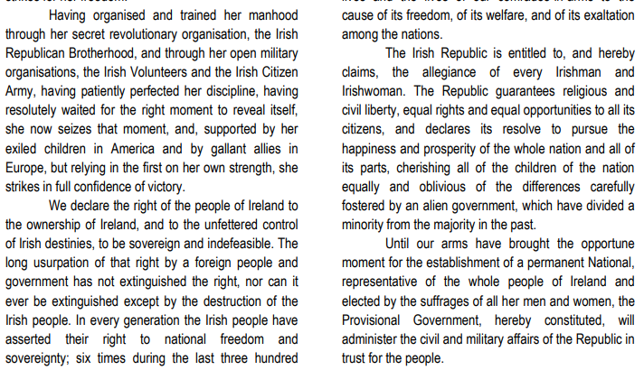
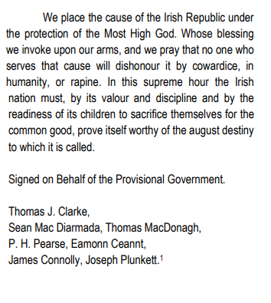
Answer the questions:
- Find the meaning of the following words in your dictionary:
- Proclamation
- Sovereign
- Indefeasible

- To whom was the Proclamation addressed to?
- What organisations had a part in the proclamation?
- What do you think is meant by ‘our exiled children in America’?
- Where were Ireland’s ‘gallant allies in Europe’?
- How many times in 300 years did the Irish people rebel?
- What did the authors mean by ‘arms’?
- How many people signed the Proclamation? What were their names?
- What title did the signatories give themselves?
- What do you think these men meant by naming themselves the ‘provisional Government?’
- What did the men that signed the Proclamation want for Ireland?
- What problems did these people see with Ireland at the time?

