Good morning boys and girls,
I hope that you and your families are all well. Thank you for all your effort so far, you’re doing great! The three teachers in 3rd class are working closely together to come up lots of new challenges for third class each week. Once again, start the week afresh and do your best, if you have work not completed from last week, don’t worry, just leave it. I really enjoyed reading through all the work that was emailed to me last week. The fact files and poems were excellent! I am asking you to email two of the following three options to me, if possible this week.
- Artwork 2. Movie/TV review 3. Your response to the Oral language topic
You can also send on the 3rd option, when it’s completed, if you like. The links for correcting your maths are in this document so feel free to correct them when you wish. It is very important to remember that you’re best effort is always good enough, try not worry about your work. Over the next few weeks and months more restrictions will be lifted in the country which is something to look forward to, as is the summer weather. I was delighted to see that many of you are trying and learning new things, you can email me if you like to tell me how you are getting on!
If you need any help or have any questions you can email me rhannan@scoilmochua.com
Kind regards,
Mr.Hannan
P.S: Try the ‘IRON MAN/WOMAN CHALLENGE’ in the PE section if you can....!!!!!!!!!!!

Subject | Content | Resources  Required
Maths | Mathemagic : Multiplication/Time  Pg. 150 Problem Solving with multiplication  Q 1-10 (Attempt as many as you can. Once you understand the strategy, you just need to know your tables to work it out. ) (Correct daily using the Answer Book)  Show your strategy in your copy. Read the question twice. Draw it out.  Look at the video again, if you’re still unsure of the method.  New Wave Mental Maths Week 30 pg 89-91  (Correct daily using the answer manual)  Tables Champion: continue daily practice with whatever page you are on.  Online Tables Games:  Revise division tables  Play “Daily ten” online or “Hit the button”  Additional resources and challenge  Broken- calculator  Bikes and trikes  Elapsed Time  (All three puzzles/challenges are available as a Pdf download by clicking on the icon). | Mathemagic  Maths copy  New Wave Mental Maths
English | Jolly Grammar pg. 60. Homophones  A homophone is a word that is pronounced the same as another word, but has a different meaning and spelling. eg. two, to, too  Jolly Grammar pg. 61 “Homophone mix-up”  Remember when parsing:  Nouns = black, verbs = red,  Adverbs = orange, pronouns = pink, adjectives= blue  Prepositions = green, conjunctions = purple  Creative writing: There is a review template on page 7 of this doc.  Write a review of a movie or TV show that you enjoyed.  Include the following:  - title  - director or producer  - main actors  - plot-what is it about/what happens..  - favourite part  - who would you recommend it for  - star rating  DEAR time - Try to set aside quiet time everyday to read a book of your choice.  Reading:”Lifecycle of the Sunflower” (see attached link)  Read the text. Answer the questions, using full sentences where appropriate. | Jolly Grammar  Dictionary  Homework copy  Jolly Grammar Teaching notes  You can write the review into your copy, or type it and include pictures if you can.
Gaeilge | Bun go Barr: “Sos do dhaidí”  Lth. 106-107 Léigh an scéal arís. Éist leis an CD track. (Re-read the story this week. Listen again to the CD track.  (Listen to the story by double clicking on the mp3 file)  Lth. 108 Answer the questions in A based on the story.  Lth. 111 Using H to help you, pick 3-5 famous people (your choice) and say what they like to do, as Gaeilge. (in Irish)  eg. Is mise David Walliams.  Is maith liom a bheith ag scríobh leabhair.  Is mise Billie Eilish.  Is maith liom a bheith ag canadh.  Make sure you use the sentence structure: “Is maith liom a bheith ag…….”  Use the verbs on pg. 140 to help you.  Éisteacht: Clár teilifíse: listen to the story 3 times and try your best to answer the questions. No need for full sentences. Do your best. | Bun go Barr  Irish or other copy
SESE | Geography: The Sun  - Earthlink pgs. 124-125. Read the information about the sun.  - Answer questions pg. 79 in the workbook, into your copy (Number 4)  History: Charles Dickens  BBC Homeschool history -  - Read the questions below.  - Listen to the podcast about Charles Dickens (and the questions).  - Pause the podcast and write your answers.  - Listen to the answers that Greg Jenner reads out and correct your work.  Questions  - When he was a boy, what was Charles’s job in the factory?  - What other name did Charles use instead of his real name  when writing his early stories?  - What was the name of Charles’s wife?  - How old was Charles Dickens when he died?  - Which of his books started as his own life story but he then got embarrassed and changed it to a made up character? | The Sun Free School Video  The Sun Video National Geographic  The Phases of the Moon  Solar Eclipse and Lunar Eclipse
Art | Choose one option or do both if you like:  - Participate in the national drawing day. Open up the link for lots of options.  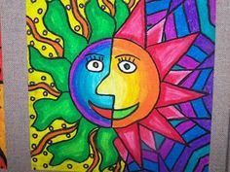  - Based on the theme of the Sun, explored in geography. Draw or paint a ‘half and half’ Sun picture. | National Drawing Day
PE | Iron Man/Woman –  - Jogging on spot ( 1 minute)  - Jump squat (30 seconds)  - Jumping jacks (30 seconds)  - Shoulder touch planks (30 seconds)  Touch your shoulder with your opposite hand while in a plank position  - Burpee (30 seconds)  Do as many rounds as you can! Aim for 5 rounds…  Youtube: PE with Joe Wicks, the body coach . Youtube
SPHE: | ‘Mindfulness for children’ with Jackie Farrell  Life skills challenge: see attached sheet

Home School Hub – Related lessons:
Monday:
As part of Home School Hub Movie Week you will be learning about different types of movies.
Múinteoir Clíona will be teaching all about the ultraviolet rays of the sun and how important it is to protect our skin.

Tuesday:
Múinteoir Ray will talk you through writing your own movie reviews and the importance of critical thinking.

Wednesday:
Today you will learn all about the solar system and where you are in it with Múinteoir John.

Thursday:
Today as part of Home School Hub Movie Week you are going to learn how to create your own movie story board.

Friday:
Múinteoir Clíóna will be teaching you about setting goals and how you can do your best to achieve them! Perhaps you can use these skills to help motivate you with your school work or taking up a new hobby or learning a new skill.

Each Friday a new quiz is put up on RTE in conjunction with the home school hub. Here is last week’s quiz, why not give it a go with your family.
Optional Work:

Oral language Activities-
- Allow your child to speak for at least 30 seconds uninterrupted about the picture below using descriptive language., predict what is happening, discuss facial expressions, emotions etc.
- Before, During and After- Allow your child to examine the picture and discuss in detail what he thinks happened before, during and after the photograph was captured.
- Pupil in role- When prompted your child must become the character in the picture and tell exactly how they are feeling. Encourage expression and drama here.
- Nosey nosey- Examine the picture closely. What do you see in the background? Do you notice anything unusual? Is there anything you didn’t see the first time etc.
e) Write down what you think the photo is about, giving it a caption and a description.

Check back on the website on Friday, to find out what the photo is actually about.

Oral language Photo

Science / Astronomy

Online planetarium - Explore the night sky and read about planets, the moon and the stars.

Science / Nature

The Natural History Museum of Ireland Virtual tour

Search the museum to find the peacock! (It’s not easy!)

Sample Film Review:

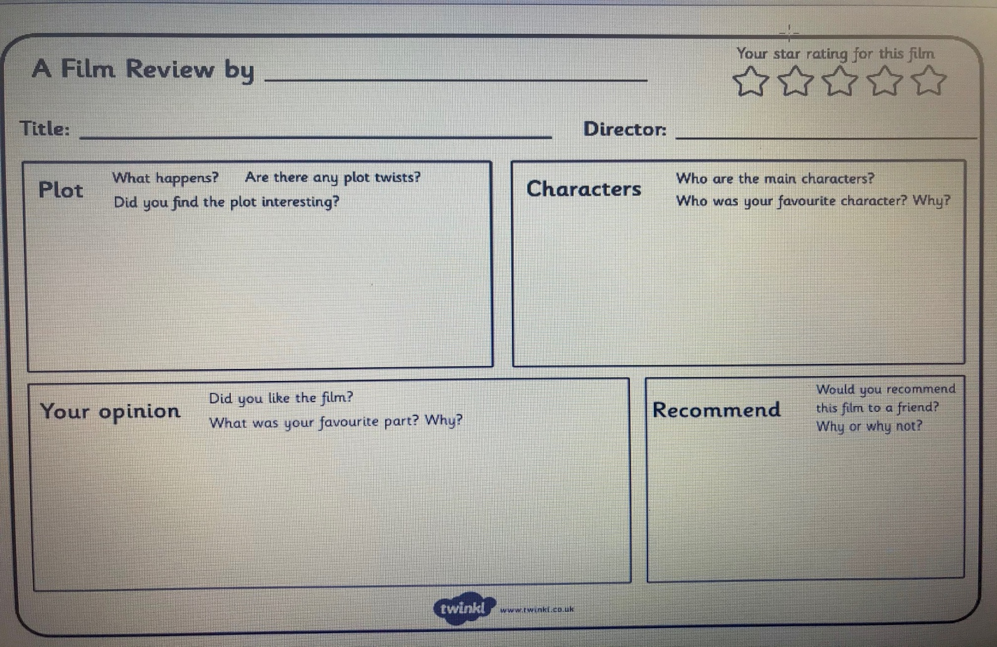
Jolly Grammar Teaching Notes:
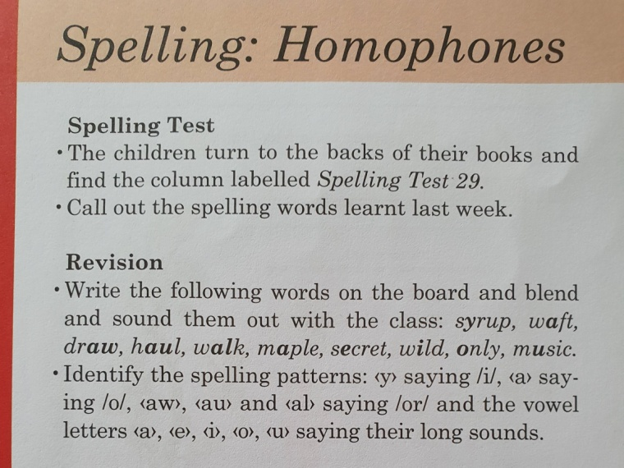  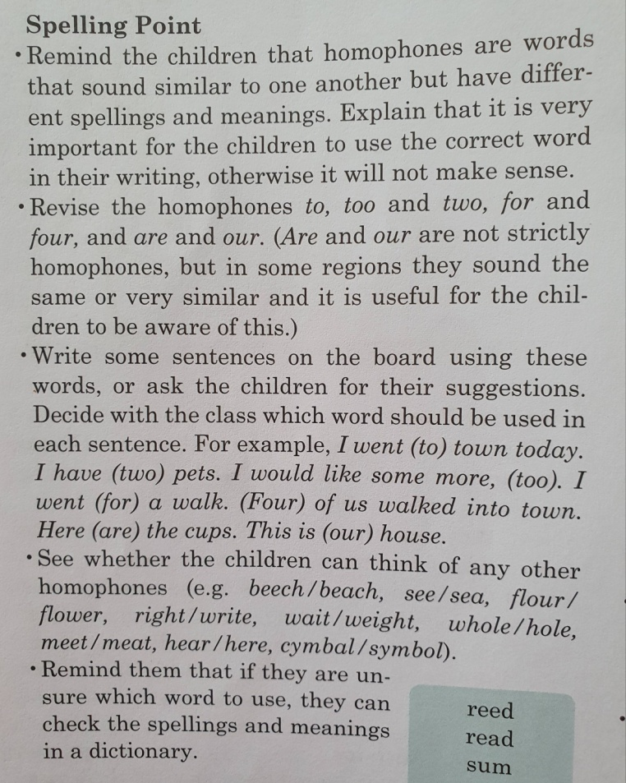 | 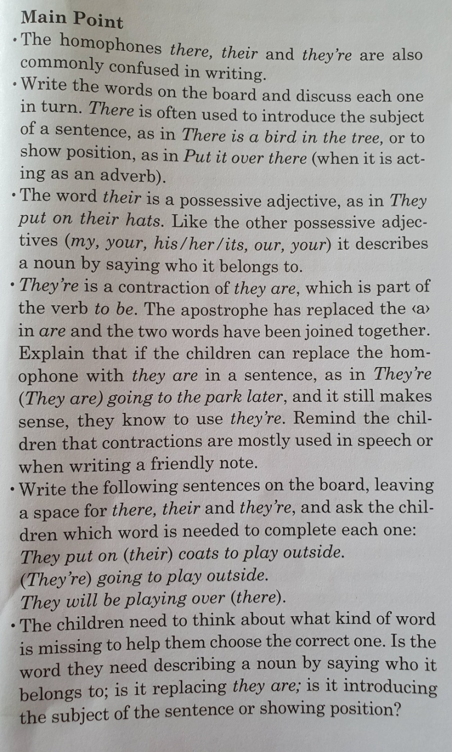
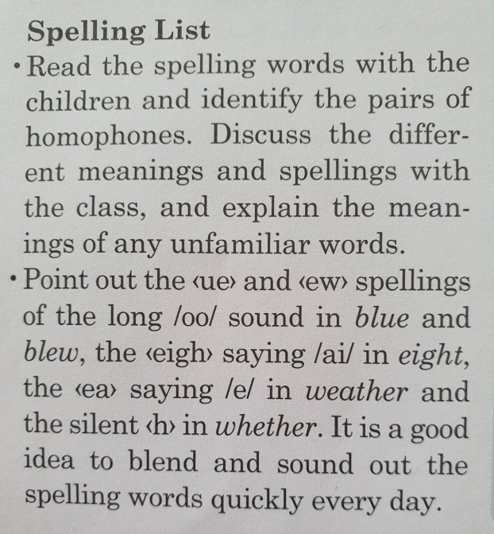 | 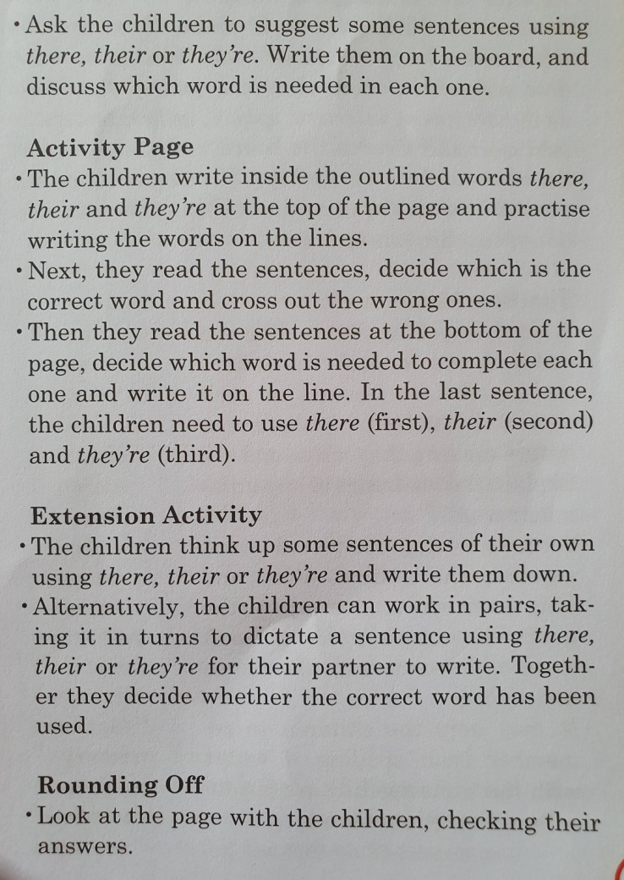
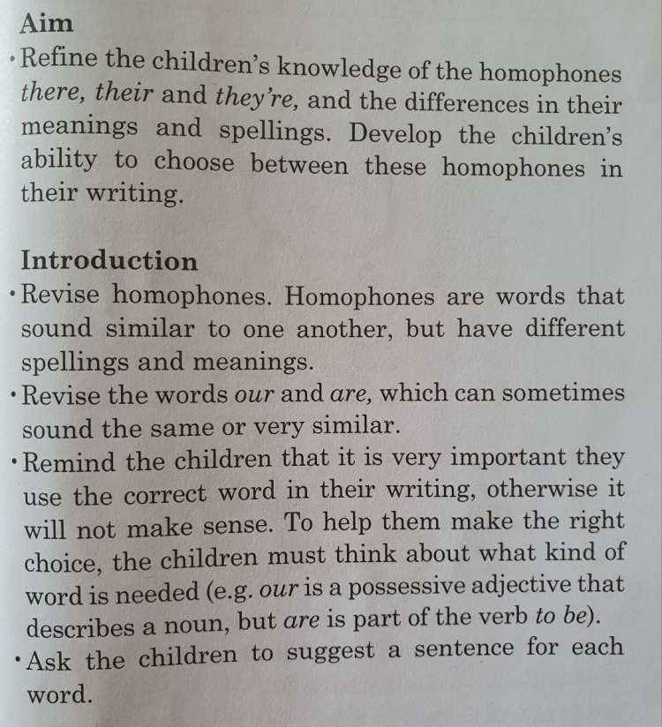

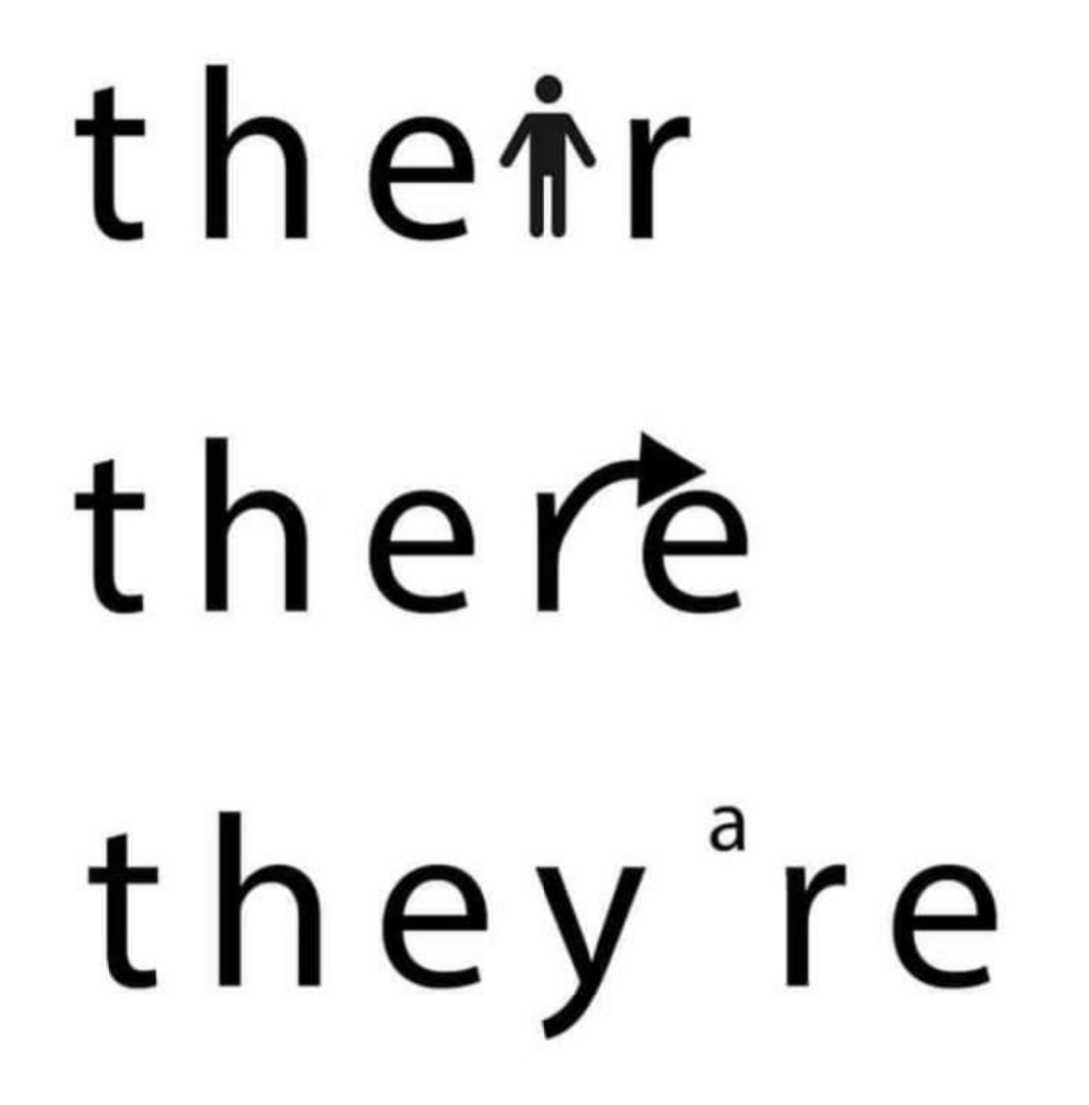
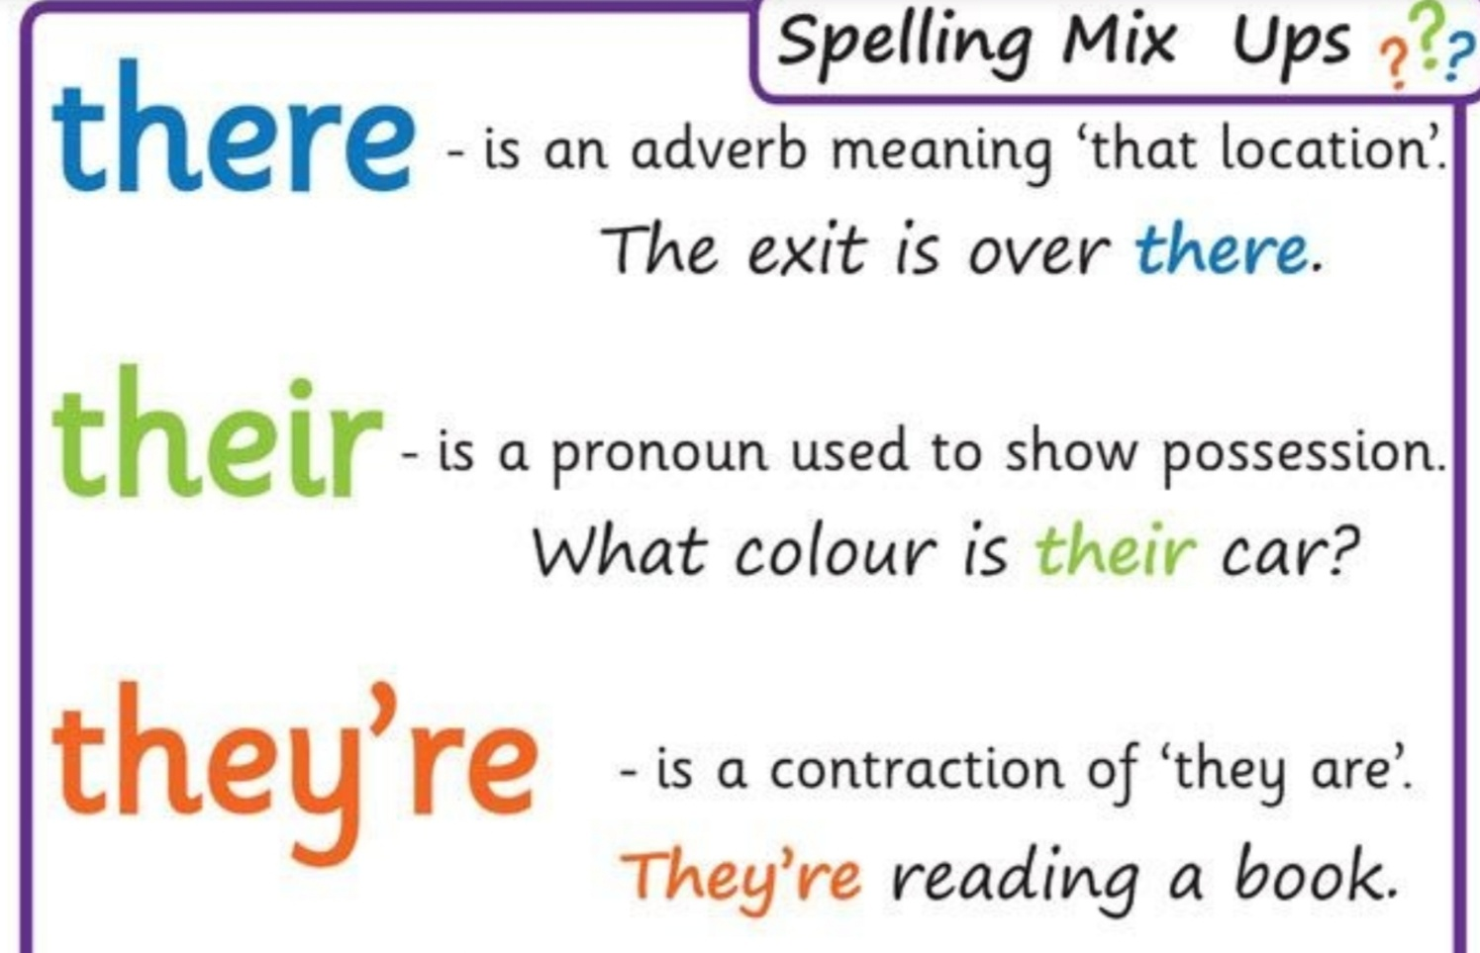

Website links embedded in this document:

New Wave Mental Maths | Answer Book
Mathemagic | Answer Book
Tables | https://www.topmarks.co.uk/maths-games/daily10  https://www.topmarks.co.uk/maths-games/hit-the-button  www.abcya.com
National Gallery | https://www.nationalgallery.ie/explore-and-learn/national-drawing-day-2020
Nation History Museum | https://www.museum.ie/en-IE/Museums/Natural-History/Visitor-Information/3D-Virtual-Visit
Online Planetarium | https://stellarium-web.org/
Jackie Farrell (SPHE) | ‘Mindfulness for children’
SPHE | Life skills challenge:
History Podcast | https://www.bbc.co.uk/sounds/play/m000j1xp
SESE links | The Sun Video National Geographic  The Sun Free School Video  The Phases of the Moon  Solar Eclipse and Lunar Eclipse
Home School Hub Quiz | https://www.rte.ie/learn/2020/0515/1138615-take-part-in-the-big-kids-quiz/

