6th class Work at Home May 11th – 15th 2020
We hope that everyone got to enjoy the sunshine over the weekend. Here is your work for the week. As usual, do what you can do. If you need help or clarification on anything, please email your teacher.
Please correct last week’s work using answers for self-correcting on the school website. This is part of your work for the week as we would like to know if you are having any difficulties.
What you will need:
Mathemagic 6
Optional: Nrich problems & Master Your maths
Maths copy
PDF of Wonder
Questions on chapters
Bun go Barr 6
PowerPoint/exercise on A.F.
Project brief etc.
Homework copy (all work apart from maths can be done here)
www.scoilmochua.com

B

Maths
- Mathemagic 6 page 161 & 162. You can skip the activities
where it asks you to build shapes with cubes, but still answer
the questions based on the pictures in the book.

Volume is the amount of space a 3D shape takes up.

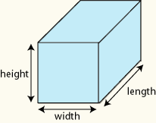
To calculate the volume of a shape we multiply length (l) x width (w) x
height (h). Volume is measured in cm³

- Practice maths facts using
https://www.abcya.com/grades/6/numbers
Math Fact Shoot-Out is a good one to try first.
Do ‘medium’ level or ‘hard’ for a challenge.

- Optional challenges: Colour Cube & Cuboid Challenge
These problems are located at the end of this outline. They can be done if you get work completed or it can be done instead of some of the work in the chapter as it is good for developing problem solving strategies.

- Optional-Master Your Maths Week 21
These exercises are also found at the end of the outline and can be done if you need extra work.

English

- ‘Wonder’. A PDF copy was attached on the outline dated 20th April.
Read Page 77 (Genetics 101) to page 97 (end of chapter The Egyptian Tomb).

You should read about 4/5 pages a day and answer the questions for the chapters, also attached, as you finish the chapters. You do not need to write full sentences.

- In Wonder we have come across a lot of similes. A simile is where something is described by comparing it to something else using the words ‘as’ or ‘like’.
Eg. As big as a house. He felt like a wet rag.
Please complete the simile worksheet at the end of this outline of work. You will see that you are asked to write a descriptive passage using similes and send it to your teacher. It can be sent via email or on Google Classroom.

Gaeilge

- Bun go Barr ‘Ticéad ar an Talamh’ leathannach 86 & 87. Léigh an scéal agus déan B & C ar lch 88 agus D & F ar lch 89.
Read the story on page 86 & 87 and do B & C on page 88 and D & F on page 89. Full sentences for B. Answers only for C, D & F.

Foclóir don scéal:
Gaeilge | Béarla
soilse tráchta | traffic lights
seanfhear dall | old blind man
ag crith le heagla | shaking with the fear
bhrúigh | pressed
láithreoir | presenter
dea-scéal | good news
an deireadh seachtaine dar gcionn | the following weekend
éadaí galánta | stylish clothes
duais | prize
ag lonradh | shining/lighting
ag rásaíocht | racing
ag scréachaíl | screeching
díreach | straight
An Bhruiséil | Brussels
cúpla lá ina dhiadh sin | a couple of days after that
lucht féachana | audience/onlookers

- Grammadach: go through Scoilnet PowerPoint on Aimsir Fháistineach (future tense), An Dara Reimniú, briathra caola (slender/narrow verbs)

- Do worksheet, at the end of the outline, out into copy. Do the part in the table orally and full sentences for questions 1-8.

SESE

- Geography-
Project on Greece-A brief and recommended websites were included with last week’s outline. We also attached various resources on different aspects of Greece. The brief is also available as an attachment this week, if needed.
Finished project can be emailed or uploaded and ‘turned in’ on Google Classrooms.

English work: Similes
A simile compares two different things using ‘like’ or ‘as’.
E.g. As big as a house. He felt like a wet rag.
We use similes in writing to make it more interesting and to help the reader get a more vivid picture of what we are talking about.
Can you finish these well-known similes with the appropriate words?
- As quiet as a ________________________.  - As slow as a _________________________.  - As brave as a _________________________.  - As blind as a ___________________________.  - As wise as an __________________________.  - As cool as a ___________________________.  - As free as a ___________________________.  - As busy as a ___________________________. | 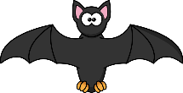
Read the following descriptive passage and underline the similes.
The sky was as dark as night. The thunder sounded like a hungry giant’s stomach grumbling. The wind cackled like a witch, making it feel like an eerie Halloween night. Lightning whipped across the sky and rain poured down as if it had never rained before. The ground was soon like a swimming pool.

Write your own descriptive passage (about a paragraph long) using similes to describe a volcano erupting and submit it on Google Classroom OR send it to your teacher by email. | 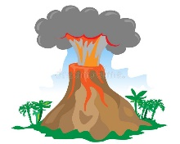

- Think about the different parts of a volcano that you could describe- smoke, lava, heat etc.
- Think about the different senses- smell, sight, and hearing will apply to a volcano erupting.
- How can you turn some basic sentences into similes? For example, the smoke was thick and black. Could you use similes to describe that even further?
The smoke was as thick as ________________ and black like ______________.

Optional Maths- Problem solving
This cube is made up from 3×3×3 little cubes whose faces are either all red or all yellow.
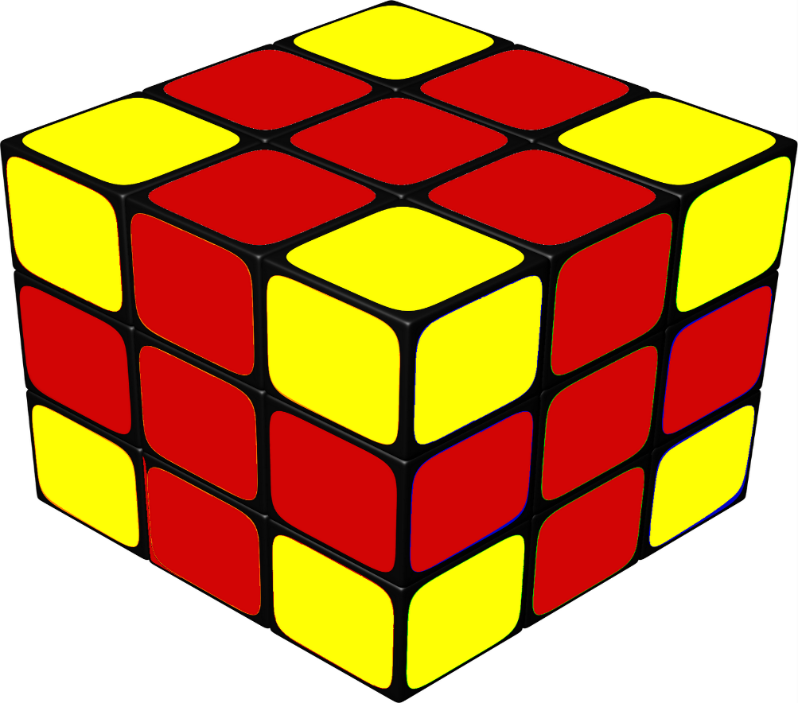
The views from all sides of the cube look like this, and the little cube in the centre is red.
How many little red cubes are used in total? How many little yellow cubes are used?
Suppose the other views of the cube do not necessarily look like this, and the little cube in the centre is not necessarily red.
What is the most and least number of little red cubes that could be used?

Optional Maths- Problem solving

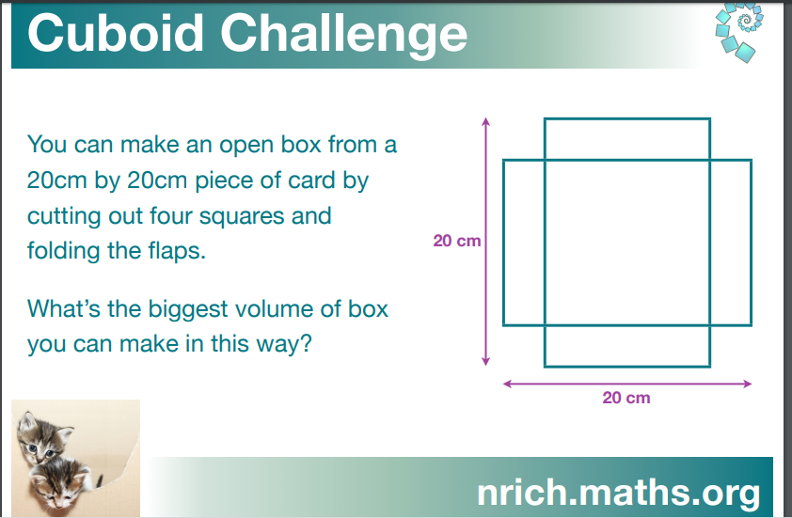

Send in a labelled drawing showing the length/width of the squares you cut off.
Highlight the volume of your box and we’ll see who sends in the picture of the box with the biggest volume!!

Optional Maths- Master your Maths
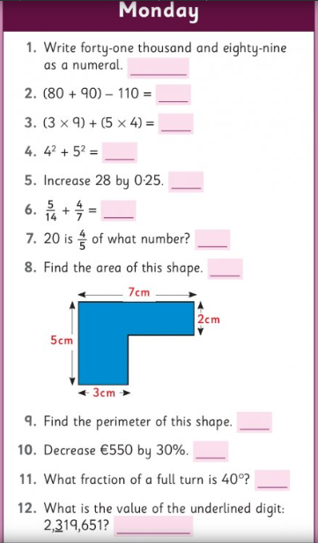
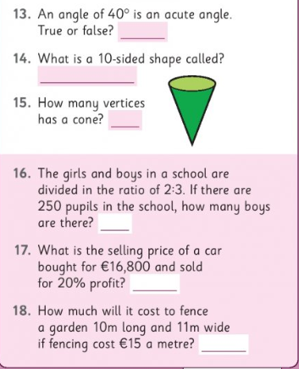
Optional Maths- Master your Maths
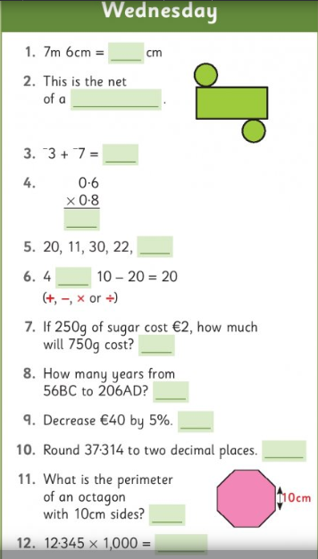
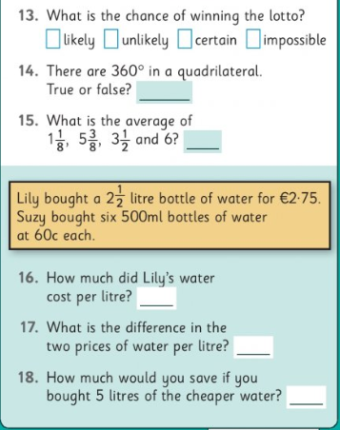

Ó Bhéal (Do orally)
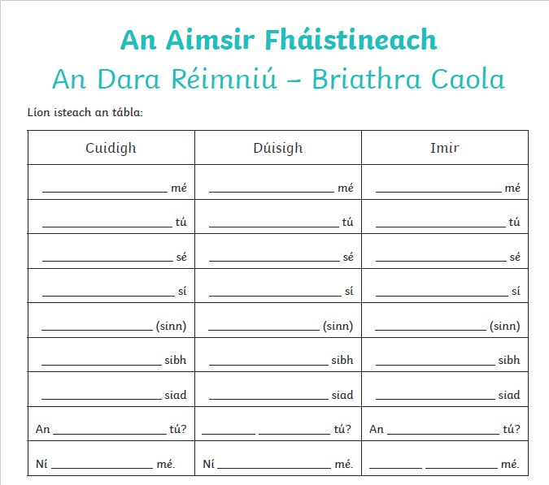
Scríobh amach na freagraí (write out)
