Personal Writing Rules
 | 3 | 2 | 1
Organisation  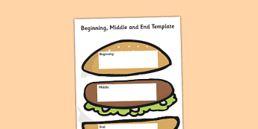 | My writing has a clear beginning, middle and end. I use transition words. | It is not always easy to tell what is the beginning, middle or end of my writing. | My beginning, middle and end are very unclear.
Content  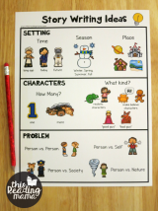 | My writing makes sense. It has many details that help the reader imagine what I am describing. | My writing mostly makes sense and has some details. | My writing does not make sense and / or has few details.
Craftmanship | My work is neat and easy to read. | My handwriting is legible but could be better. | My work is difficult to read.
Mechanics | All my sentences have full stops and capital letters in the right places. My spelling is good. | Most of my sentences have full stops and capital letters in the right places. Most of my spelling is good. | My writing is missing many capital letters and full stops. My work has many spelling errors.

Total

