Similes
A simile compares two different things using ‘like’ or ‘as’.
E.g. As big as a house. He felt like a wet rag.
We use similes in writing to make it more interesting and to help the reader get a more vivid picture of what we are talking about.
Can you finish these well-known similes with the appropriate words?
- As quiet as a mouse.  - As slow as a snail/tortoise.  - As brave as a lion  - As blind as a bat.  - As wise as an owl.  - As cool as a cucumber.  - As free as a bird.  - As busy as a bee. | 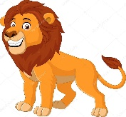  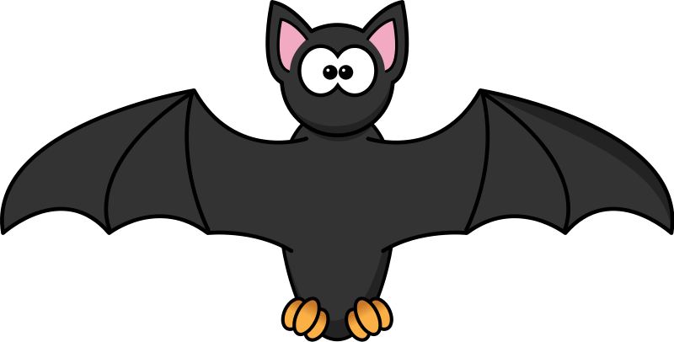
Read the following descriptive passage and underline the similes.
The sky was as dark as night. The thunder sounded like a hungry giant’s stomach grumbling. The wind cackled like a witch, making it feel like an eerie Halloween night. Lightning whipped across the sky and rain poured down as if it had never rained before. The ground was soon like a swimming pool.

Write your own descriptive passage using similes to describe a volcano erupting and submit it on Google Classroom OR send it to your teacher by email. | 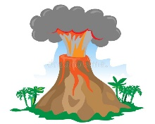

- Think about the different parts of a volcano that you could describe- smoke, lava, heat etc.
- Think about the different senses- smell, sight, and hearing will apply to a volcano erupting.
- How can you turn some basic sentences into similes? For example, the smoke was thick and black. Could you use similes to describe that even further?
The smoke was as thick as ________________ and black like ______________.

