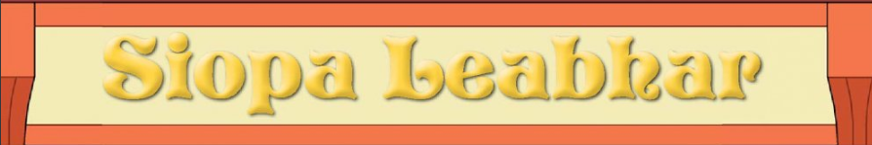
Listen to the story and try your best to answer these questions:
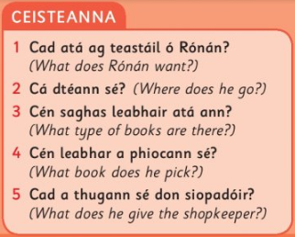
Some vocabulary translated:
