Small World
Unit 12, Greece
We did not give the questions on page 69 to do, but we meant to. You got off lightly there. Read over the questions in the book to make sure you know the answers orally and check them below.
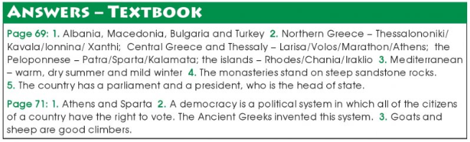
4. The soil in Greece is poorer quality than in Ireland, as it does not get enough rain, so there is much less land used for farming. However, it has a very dry climate so it can grow many products that do not grow well in colder, wetter climates, such as in Ireland. You might not have known this but crops that grow well in dry climates, such as Greece, are olives, corn (maize), wheat, barley, sugar beets, peaches, tomatoes, cotton (of which Greece is the only EU producer), and tobacco. There are many others mentioned in the book. We can grow these crops in Ireland but to a much smaller scale and we would need a greenhouse to grow fruits, such as tomatoes and peaches, properly. Greece produces enough to export many of these products.
** If your answer highlights some of the points above, mark it right.

