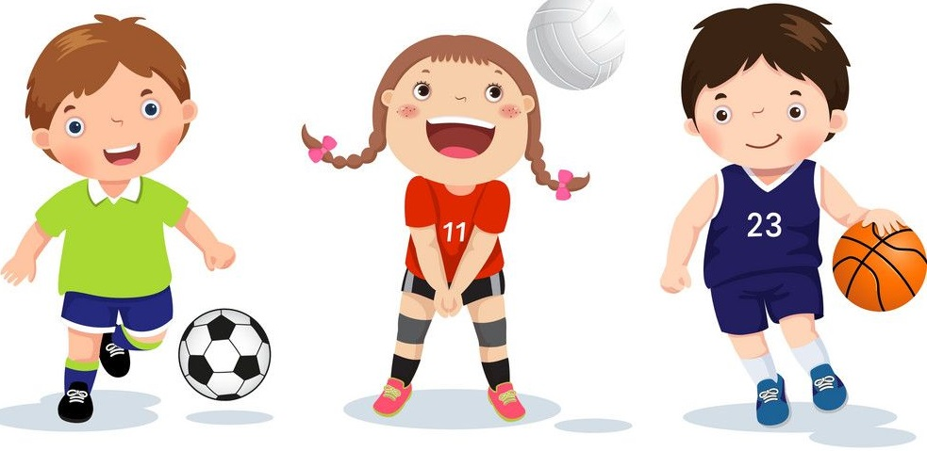

Choose from the Activities and challenges below, try as many as you like.
You could also try some of the activities from ‘Sports Day At Home’.
5 km Run/Walk Challenge
- Set a target on Monday and try to reach your target distance by Friday.
- Your target could be 2km or even 10km! Whatever you think you can achieve.
- Try to run or walk a bit each day, you could get your siblings, parents or even your dog involved!

Activity circuit - Using the ‘Activity Circuit’ cards, try to do each activity, one after another. Repeat the circuit as many times as you like.
Long Puck –– You’ll need a hurl and a ball and in a safe, open, outdoor location. See how far you can hit the ball or find a partner and hit the ball to each other.
Welly Toss – In a safe, open, outdoor location, put on one welly and fling it, from your foot, as far as you can. See who can fling it the furthest!
Balance challenge – Standing on foot, time yourself and see how long you can balance.
Target challenge – In safe area, and with permission, choose a target (a hula hoop, a skipping rope/chalk circle), place down a marker a short distance from the target and see how many objects (bean bags, pegs, etc) you can get into the circle, in a minute.
Kids Yoga – Try a series of yoga poses using the ‘Yoga’ Power point.
Scavenger Hunt – Complete a scavenger hunt using the ‘Scavenger Hunt’ activity card.
Sports:
Football Basketball Gymnastics Hockey
Hurling/Camogie Gaelic Football Rugby Swimming
Dance Handball Tennis/Badminton Judo/Karate

