St. Brigid
Characteristics of Brigid
According to Eileen Deegan's book of Parish Rituals, St Brigid can be described using the following five characteristics:
(1 ) Earthwoman
Brigid is considered to be the patroness of cattle and dairy work and has long been associated with farming and fishing. The feast of St Brigid marks the end of the dark winter days and the coming of the light. This is not just a sign of new light but is a time of new birth: lambs and calves in particular. In Galway, there was a custom of taking some of the grains or seed from the sheaf that was used for the making of the St Brigid’s crosses and placed beside the Cross until sowing time. Then these seeds would be added to the new seeds being sown. Also, any little bits that were left over from making the St Brigid’s crosses were placed in the bedding for the animals by way of protection for the animals.
(2) Hospitality
Brigid gave food to the hungry, came to the aid of those in need and encouraged people to care for those in need. She also offered healing where ever she could. Regularly she gave away most of her family’s food. Her mother was a slave and so Brigid learned a lot about being of service to others. She assumed this role of service when her mother became ill and then after she passed away. This compassion lived on when she had her own monastery.

(3) Peacemaker
Brigid was often called on to settle disputes between people. Sometimes, mist would fall between two disputing groups. She tried to sow peace and avoid bloodshed at every opportunity. The following is an example of Brigid the peacemaker:
Brigid was teaching a group of people about God when she noticed nine men dressed in particular guise who were shouting in a grotesque and offensive way and destroying everything in their paths. When the most wicked vows and oaths to the devil who possessed them they thirsted for bloodshed and planned the slaughter and murder of other people. Brigid spoke to them that they might abandon their warring ways and repent. But they refused to do so. Brigid prayed and prayed to God for them, and eventually in their dreams they committed the bloodshed, but never in fact murdered anyone. When they realised what had happened they came back to thank Brigid and were filled with peace and repentance. (http//ri.bne.catholic.edu.au)
(4) Compassion
Brigid opened her heart, her home and her arms to people in need. Alexander Carmichael once wrote: Brigit with her white wand, is said to breathe life into the mouth of the dead Winter and to bring him to open his eyes to the tears and the smiles, the sighs and the laughter of Spring.’ She made St. Brigid’s crosses for the sick and the dying so that they were reminded of the hope that we are united with Christ through our suffering and once we pass from this life to the next, life would be ‘changed and not ended’. She was devoted to the care of the sick, the elderly, the dying and those who were in need in any way.
(5) Healer
A Brat (piece of Ribbon) is a reminder of the healing power of St. Brigid. It was thought that leaving the Brat at the doorstep or on the window sill on the eve of St Brigid’s Day, it would be touched by the saint when coming into the house. This Brat was used for medical problems such as toothache, headache, earache and a sore throat. Also, it was thought to help women who could not have babies to become pregnant. The Brat was also used to cure farm animals.
FOR YOU TO DO:
- Research a story about St. Brigid not mentioned in the above material.
- Look at the following table and insert the name of a celebrity who has each of the characteristics.
Earthwoman | Hospitality | Peacemaker | Compassion | Healer

- Is there any celebrity who has all five of these characteristics?

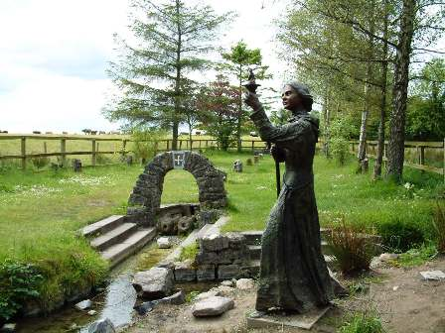
For a visual example of the characteristics of St Brigid, visit St Brigid’s Well, at St Brigid’s Cathedral, Co.Kildare. There are five prayer stones which allow you to reflect on elements of St Brigid’s life. Stone One: Brigid the Woman of the Land; Stone Two: Brigid the Peacemaker; Stone Three: Brigid the Friend of the Poor; Stone Four: Brigid the Hearthwoman and Stone Five: Brigid, Woman of Contemplation.

FOR YOU TO DO:
- Choose one of the following customs associated with the feast of St Brigid.
- Give an account of the customs and give an example.
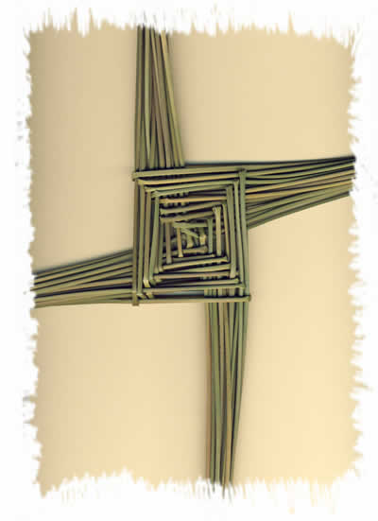
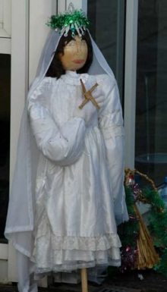

St Brigid’s Cross The Brídeog
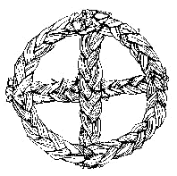
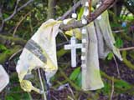

Brat Bríde Crios Bríde

