Monday 27th April, 2020
Good morning to all the boys and girls in room 15,
Thank you to those of you who sent me on some of the work that you completed, recently. It’s great to see that you’re all doing your best and keeping motivated. I know it’s very different to being in the classroom with your friends, but try and remain positive. We’re all in the same boat! The weather has been so lovely. I hope you’re all getting out in the fresh air and exercising in whatever way you can.
The following is an outline of the work that I would like you to do for next week, starting today Monday 27th. Please try and complete some or all of it. Do your best and keep up the effort. If you run out of room in a copy, just use another one. Don’t worry about things like that! The School Hub at 11am daily is really good too!
I have included a sample timetable at the end of this document. It’s completely optional and if it doesn’t suit your household, that’s absolutely fine. It might help though, to put some structure on the day.
Hope you’re all keeping well. Remember to read every day as well!
And remember to wash your hands regularly and continue to practise good cough and sneeze etiquette.
N. Brennan

Subject | Content | Resources Required
Maths | Money:  Mathemagic  pg 142 Q. 1 -3  pg 143 Q.1 – 8  New Wave Mental Maths Week 28 (including problem solving and Friday tests)  Revise division and multiplication tables  Play “Daily ten” online or “Hit the button” https://www.topmarks.co.uk/maths-games/daily10  https://www.topmarks.co.uk/maths-games/hit-the-button  Additional resources and challenges:  Maths puzzles – 3 problems included at the end of this document | Mathemagic  Maths copy  New Wave Mental Maths
English | Jolly Grammar page 54 “<y> /i/ ” sound  Jolly Grammar activities pg 55  (The object pronouns are written in pink beside the bees!)  Reading Zone Unit 28. “Clever Rosa”  (The 3 teachers from 3rdclass have decided to work on the same units- for this reason we will skip Unit 26 and 27 for now but will most likely come back to them later in the year)  A - your answers should be in full sentences, remember the reader should know what the question is from your answer.  B - write the sentence and underline the word you choose with the letter at the end of the sentence.  C – Write full sentence and underline the word you choose.  D – Write the letter and associated answer – no need to write the question out.  E – re-write the plurals of the words in bold, there is no need to rewrite the entire sentence.  Narrative writing – Inspired by the Reading Zone story, ‘Clever Rosa’, write a short story from a trolls point of view.  As usual, plan your story with a beginning, middle and end. Make sure you plan your characters, settings, an object(something that is important in the story- an item, something magical or special), a problem (connected to the object or special item) and solution.  Use plenty of different adjectives, verbs and sentence starters like: suddenly, next, all of a suddenly, immediately, presently..  (all of which we have practised in our narrative writing in class. Remember to stop and read over what you have written every few sentences, use paragraphs if you can, use your dictionary for spelling challenging words)  DEAR time every day-your own choice!
Gaeilge | Bun go Barr: Lth. 102 (F) Write a sentence for each day of the week.  Start with a verb (Look at list on pg 138 to help).  Example:  1. An Domhnach a bhí ann. Chuaigh mé go dtí an pháirc.  Lth. 103 (G) Write the words in order  e.g.: 1 - lámhainní  2 - ________  You can draw pictures of the éadaí, if you wish, in your copy and label them.  Léigh an scéal – Sneachta ( Read the story only. I know we did this story in class after Christmas, but as the 3 third classes are doing the same work, you have the advantage of having read the story already!)  Listen to the story by double clicking on the mp3 file | Bun go Barr  Irish copy or homework copy
SESE  SPHE  Art  PE | Homeschoolhistory – Children’s History Podcast  Available on BBC website every Monday – ‘The Space Race’  https://www.bbc.co.uk/programmes/m000hmmd  ‘Mindfulness for children’ with Jackie Farrell, who worked with our class in the school this year.  https://www.youtube.com/channel/UCe27J_QvPd9nX4_WzMpGYqw  Based on the theme of ‘Earth Day’, which took place on Wednesday the 22nd of April. Draw or paint a picture a picture of an endangered animal, for example, a tiger, an orang-utan, an elephant etc...  Helpful links if looking for inspiration:  https://youtu.be/T8KCbYc7lB0 Orang-utan  https://youtu.be/mwwZ3sAn3ZQ Tiger  https://youtu.be/MBzd0piFzR4 Cheetah  Youtube: PE with Joe Wicks, the body coach  Daily walk/cycle/football or hurling/camóige skills practice. Jump on your trampoline..play road tennis, badminton…  Sample of possible timetable to help organise your time.  Time Weekday  9:00 – 9:30 Exercise to wake the body up - Joe Wicks. (Make sure you hydrate yourself!)  9:35– 10:15 Mental Maths/tables revision/Mathemagic  10:15-10.30 DEAR time  10:30-10.50 Gaeilge  10:50 -11:00 Short break before Home School Hub /Snack  11:00-12:00 Home school Hub  12:00 – 1:00 Lunch break Get some fresh air if you can  1:00 – 1:30 Reading Zone  1:30 -2:00 Get creative - Art activity/music /baking  2:00 – 2:20 SESE/project work  2:20 -2:40 Jolly Gram- sps-  Play with your siblings, do jigsaws, puzzles, lego building, colouring to calm the mind, science experiments, arts classes (art hub), chores – helping out at home.  My advice is to break up the day into small parts. Give set times to work on different subjects and stop once the time is up. But ultimately, do what suits your child and household best. It’s not school and it’s difficult to re-create it at home!  Additional Maths Challenges (April 27th – May 1st)  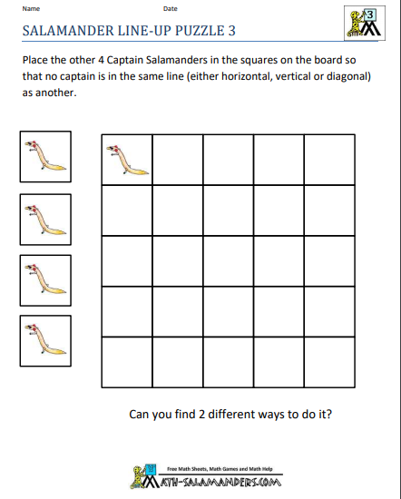  To complete this without printing draw a grid with 5 boxes going across and 5 going down. Place small objects in the grid if you wish to be able to move them around or simply draw an x in place of the salamander.  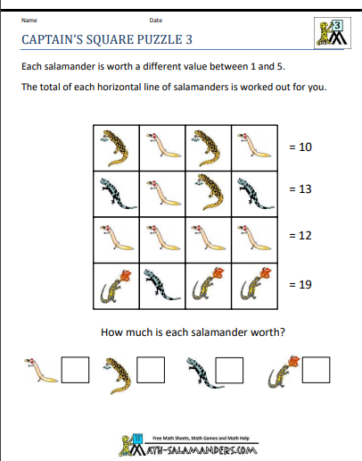  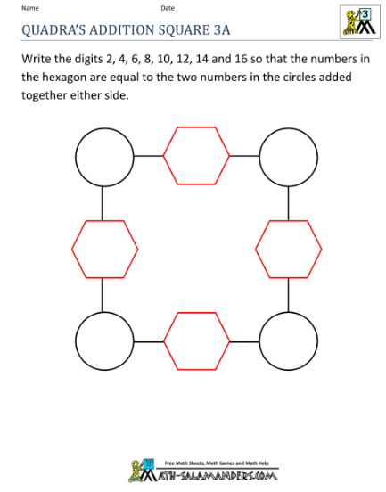 | A4 page or similar

