Hi, girls and boys. I hope you had a nice Easter. I hope you are all well and helping out at home. Below is a list of work for this week, try your best with it. Again, any work should be done in your ‘Special copy’ that you brought home. Try your best with it and ask for help if it is needed. Don’t worry if you cannot get it all done; just make your best effort, as always. I have included ‘optional work’ again, which you do not have to do; it is just a few fun things you might like to try. Try to read every day if you can and make sure to get out for some fresh air!!!!
** I will post the answers to this week’s Maths, English and Gaeilge work on the school website, on Friday. **
If you or your parents have any questions or queries about your work, your parents can e-mail me at rhannan@scoilmochua.com.
English: Reading Zone - Unit 27
Questions A (Full sentences) B,C,D,E (words only)
Jolly Phonics - pg 52 + 53
(The subject in a sentence is the person or thing that is doing something, the object is having something done to it.)
Michelle kicked the ball. Michelle= subject Ball=object

Creative Writing: Diary Entry
Write about what you did on one day this week.
Be sure to write the diary entry in the past tense, imagine you are talking to somebody, include the day and date and the different things you did. You can complete the work in your copy, or you can type it and e-mail it to me if you wish. Helpful hints below.
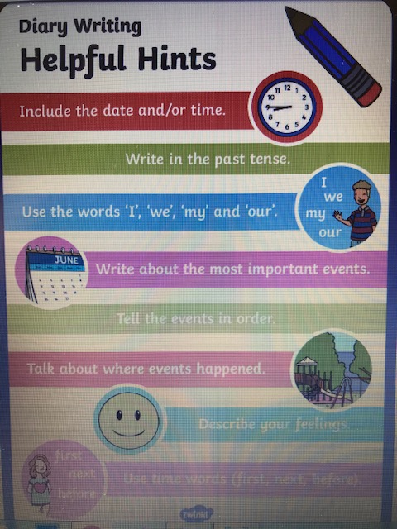

Maths: Mental Maths pg 80-81
Mathemagic – pg 140 Q. 1 – 4 (do a-e) in each question
pg 141 Q.1 – 2
Revise Division Tables (abcya.com)
Gaeilge: Bun go Barr
- Lch. 94 + 95 A. Léigh an scéal B. Cúpla ceist (1-6)
If you find some of the questions tricky use pg 137 at the back of Bun go barr.
- Lch 96 D. Scríobh 8 abairtí/ Write the sentences.

Science: Earthlink pg 32 + 33 ‘Skin and Hair’
Read and complete questions 1-5. If you wish you can draw your own diagram of the surface of the skin under the questions in your copy.
Earthlink Workbook: pg 20 (Write in the workbook)

History: Read pg 118- 119 (Read only)

Optional Work
Optional Work: (You do not have to do this, you can choose do some, all, or none)
History:
Homeschoolhistory – Audio which is very fun and entertaining https://www.bbc.co.uk/programmes/m000hmmf/broadcasts/upcoming
Science:
Virtual Tour of the Natural History Museum in Dublin.
https://www.museum.ie/Natural-History/Exhibitions/Current-Exhibitions/3D-Virtual-Visit-Natural-History Extra challenge: Can you find the Hippo?

PE Youtube – P.E with Joe Wicks (The body coach TV)
Art
Draw a picture based on the photo of Celbridge in 1901 below. Feel free to add colours. If possible, you can e-mail a photo of your finished picture to me! That would be great!
