6th class Work at Home May 18th – 22nd 2020
We hope that everyone enjoyed the weekend. Here is your work for the week. As usual, do what you can do. If you need help or clarification on anything, please email your teacher.
Please correct last week’s work using answers for self-correcting on the school website. This is part of your work for the week as we would like to know if you are having any difficulties.
What you will need:
Mathemagic 6
Optional: Master Your Maths
Maths copy
PDF of Wonder
Questions on chapters
Bun go Barr 6
PowerPoint on Irish verbs.
From Big Fish to Little Fish
Project brief etc.
Homework copy (all work apart from maths can be done here)
www.scoilmochua.com

B

Maths
- Mathemagic 6 pages 143 (do no. 1 orally), 144 & 146.

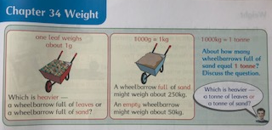
- Practise maths facts using
https://www.abcya.com/grades/6/numbers
Math Fact Shoot-Out is a good one to try first.
Do ‘medium’ level or ‘hard’ for a challenge.

- Optional-Master Your Maths Week 22
These exercises are also found at the end of the outline and can be done if you need extra work.

English

- ‘Wonder’. A PDF copy was attached on the outline dated 20th April.
Read Page 97 (start of Part 4 Jack) to page 132 (end of The Boyfriend).

You should read about 6/7 pages a day and answer the questions for the chapters, also attached, as you finish the chapters. You do not need to write full sentences.

Gaeilge

- Bun go Barr ‘Lá gan Éide Scoile’ leathannaigh 98 & 99. Léigh an scéal agus déan B & C ar lch 100 agus D & E ar lch 101.
Read the story on pages 98 & 99 and do B & C on page 100 and D & F on page 101.

Foclóir don scéal:

Gaeilge | Béarla
Éide scoile | school clothes
gorta | famine
an lár dar gcionn | the following day
bocht | poor
aisteacha | unusual/strange
Shocraigh siad | they decided
An oireann sé dom? | does it suit me?
cuaráin | sandals
sár i bhfad | before long
an cuairteoir | the visitor
grianghrafanna | photographs
seic | cheque
ag fáil bháis | dying

- Grammadach: go through Scoilnet PowerPoint on Na briathra neamhrialta (the irregular verbs).

- Do the Exercise in Bun go Barr page 76 K (make sure you write the story out in the aimsir fháistineach).

SPHE
- We are attaching a pdf of a booklet to help you get ready to move from primary school to secondary school. It is called from ‘From Big Fish to Little Fish’ (My Workbook About Moving from Primary to Secondary School)
Read and complete the activities from page 1 to page 5

SESE
- Continue with Project on Greece due at the end of the week.

Optional maths: Master Your Maths Week 22
Helping hints:
Q3. The square root of a number is a value that can be multiplied by itself to give the original number.
The square root of 9 is 3, because when 3 is multiplied by itself, you get 9.
Q.8 HCF stands for Highest Common Factor.
Factors are numbers which you can multiply together to get another number.
For Example : The numbers 2 and 3 are factors of 6 because 2 x 3 = 6.
A number can have many factors!
Example : 2 and 4 are factors of 8, because 4 x 2 = 8
Also 1 and 8 can also be factors of 8, because 1 x 8 = 8
Therefore 1, 2, 4, 8 are all factors of 8
Q.15
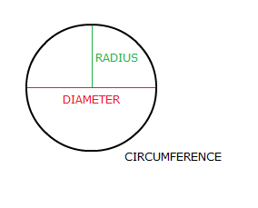
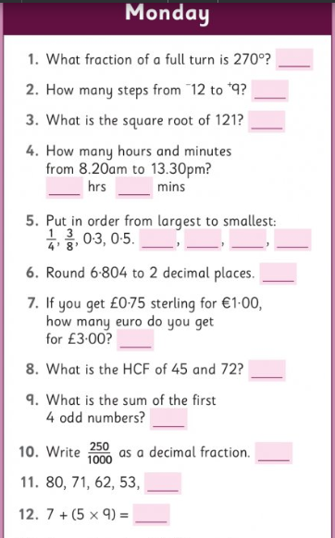
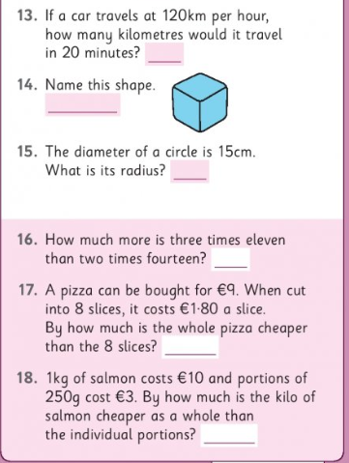
Optional maths: Master Your Maths Week 22
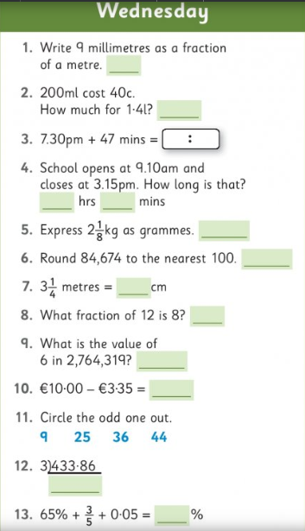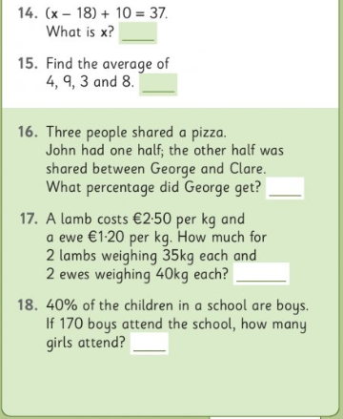
Helping hints:
Q1. There are 1000mm in a meter
Q14. x is the same as an empty frame or box □
So, it is the same as
(□-18) +10=37
Hint: work backwards. When you work backwards do the opposite operation.

